Exercises: Full-Stack Apps with Next.js
Exercises and homework assignments for “Full Stack Apps with AI” course at SoftUni.

Create Next.js App by Hand
In this exercise we shall build a few Next.js pages + site layout by hand (without AI prompts):

Step 1. Setup a New Project
Create a new workspace in VS Code, e.g. `play-with-nextjs`:
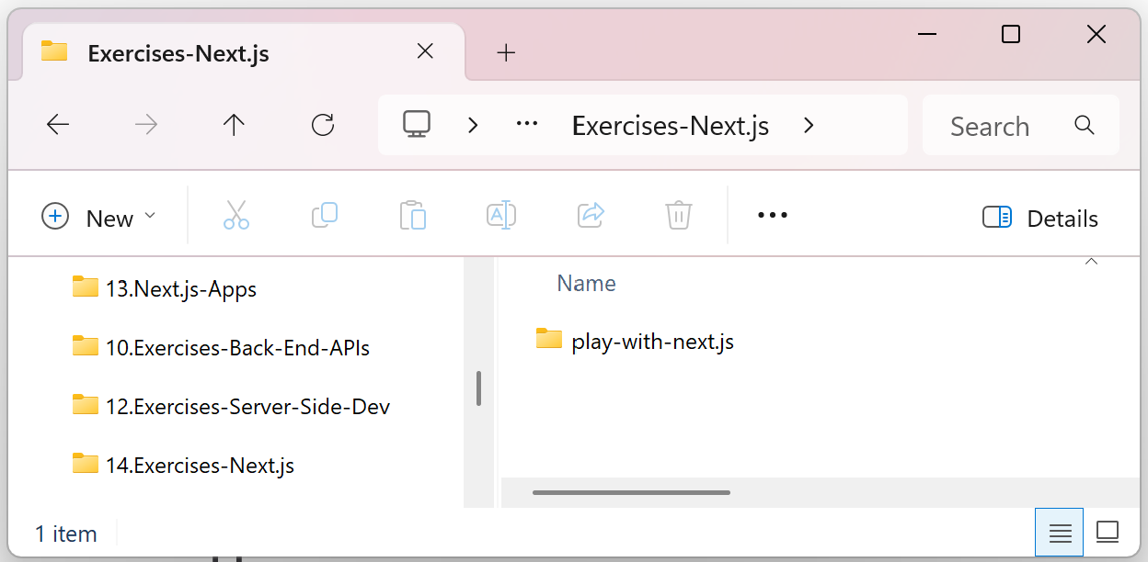
Initialize a Next.js project with TypeScript, Tailwind and App Router. Use the following Terminal command:
npx create-next-app@latest
Accept the recommended default settings:
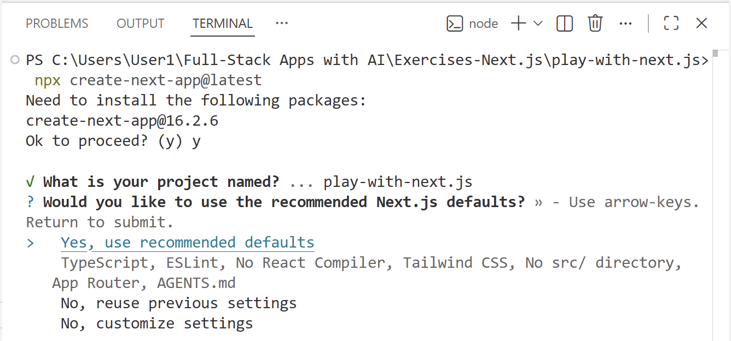

Step 2. Add Pages
Note: Work manually (by hand), without AI prompts.

The Home Page
Change the page content of the app "Home" page: /app/page.tsx
- Insert <h1>Welcome<h1> + <p>Welcome to Next.js</p>
Open the `App` folder, then `page.tsx` and then edit the default text in the <main> segment. You can then delete some of the sample content generated like images and buttons:
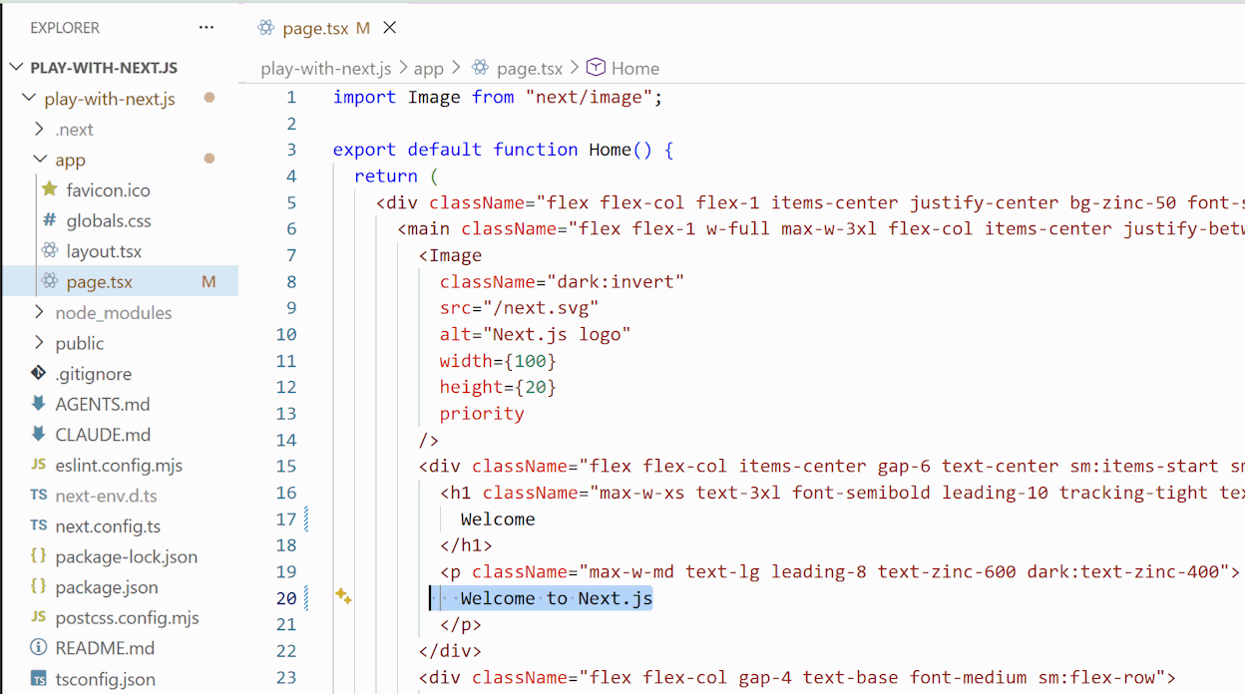
You can then delete some of the sample content generated like images and buttons:
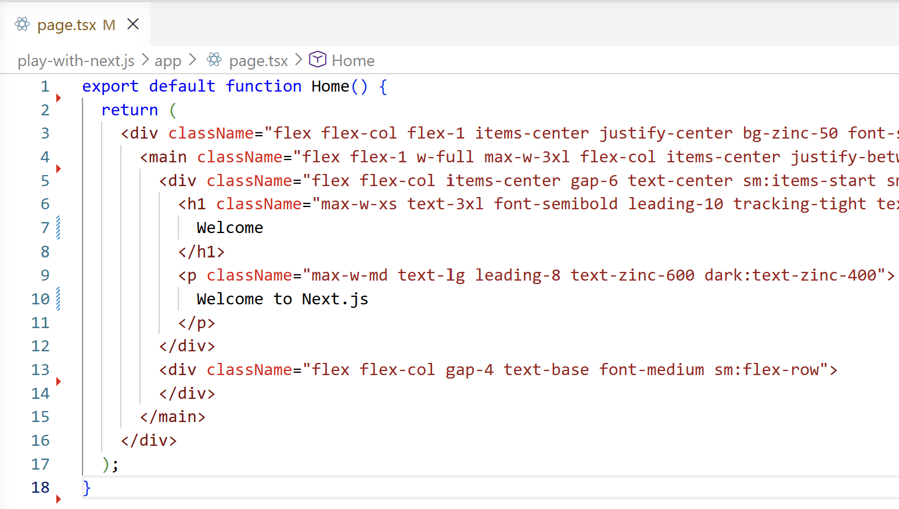

The About Page
Create a new page "About": /app/about/page.tsx
- Insert <h1>About<h1> + <p>I love Next.js</p>
In the `app` folder, create a new folder `About` and inside create a page.tsx file. Paste the following code:
export default function AboutPage() {
return (
<main className="p-8 text-center">
<h1 className="text-4xl font-bold">
About
</h1>
<p className="mt-4">I love Next.js</p>
</main>
);
}
The file should look like this:
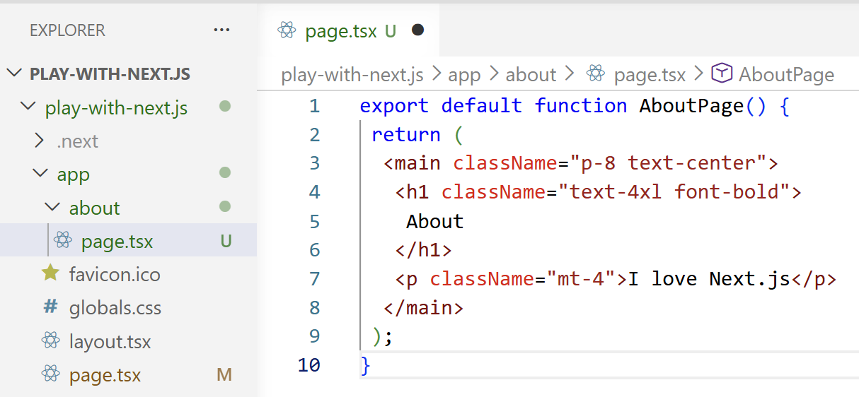

The Contacts Page
Create a new page "Contacts": /app/contacts/page.tsx:
Insert a sample contact page content like this:
<h1>Contacts<h1>
<p>Contact me: someone@gmail.com</p>

Step 3. Test the App Pages
Use the `npm run dev` command to test the pages:

Test the Home Page
The Home page should be located at https://localhost:3000/ and look like this:
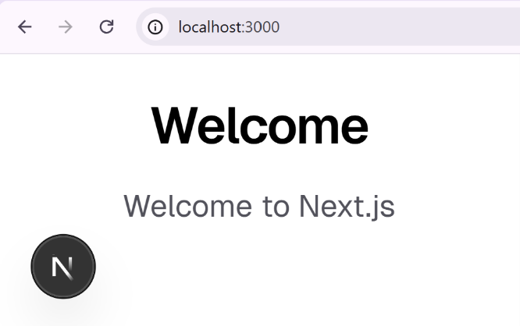

Test the About and Contacts Pages
The pages should be located at https://localhost:3000/about or /contacts and look like this:
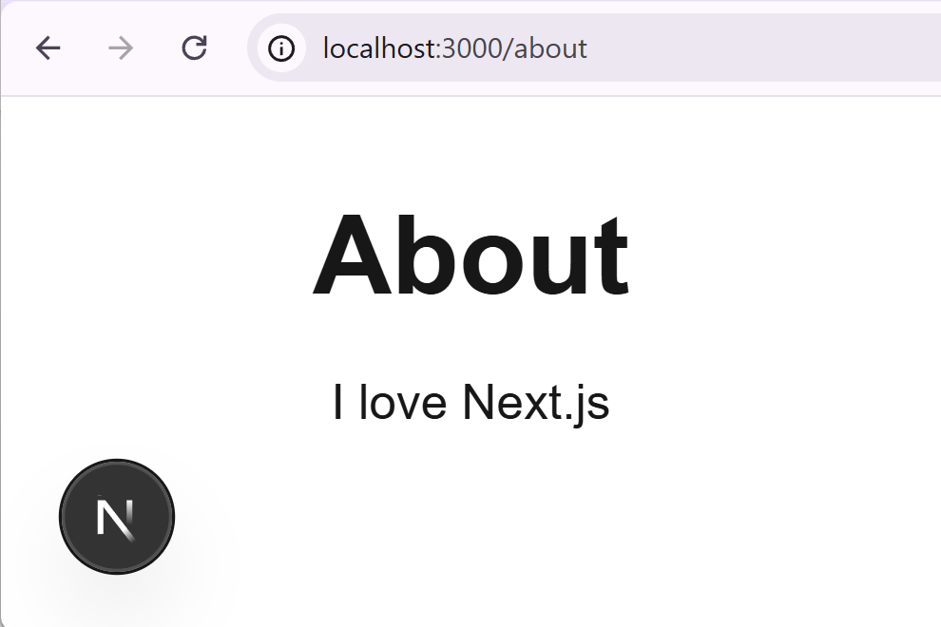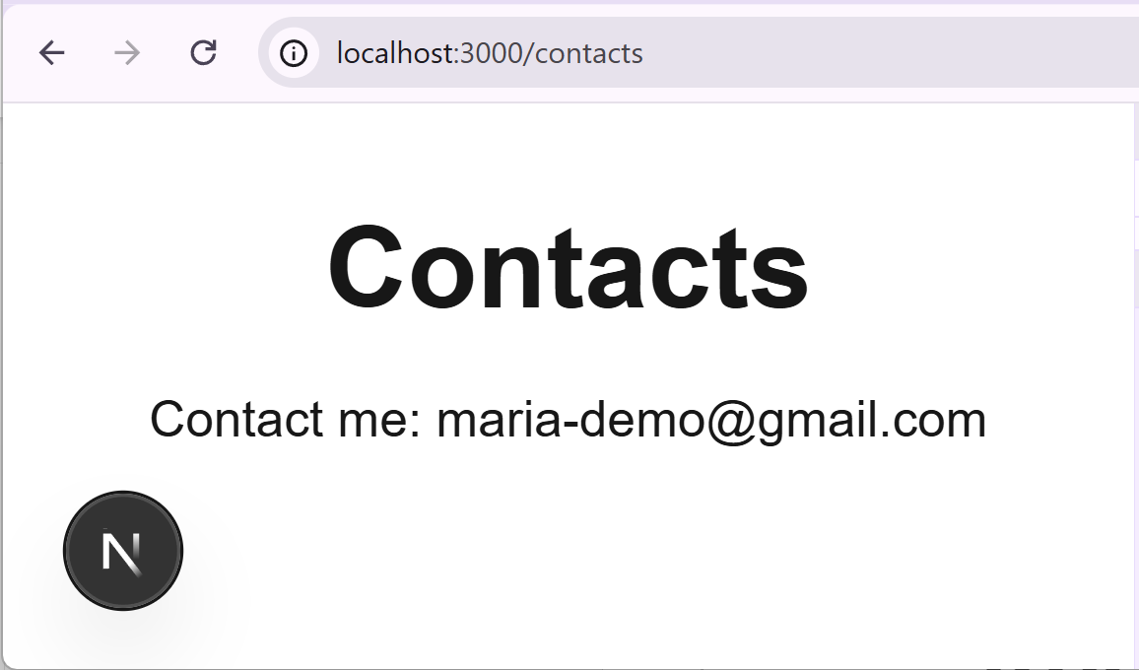

Possible Errors and Solutions
In case the formatting doesn’t display properly, there may have been an error during the Tailwind setup. Here is an easy fix: stop the Next.js server, delete folder `.next`, then install npm dependencies and start the server again:
Stop the server with the [CTRL] + [C] key combination. Run the following command to delete the `.next` folder:
- Remove-Item -Recurse -Force .next
Install NPM dependencies:
- npm install
Run the Next.js dev server:
- npm run dev

Step 4. Edit the Layout
Modify the site layout: /app/layout.tsx. Implement site header + footer:
- Header links:
  - Home
  - About
  - Contacts
- Footer (copyright message)
Before the edits, the layout.tsx file should look like this:
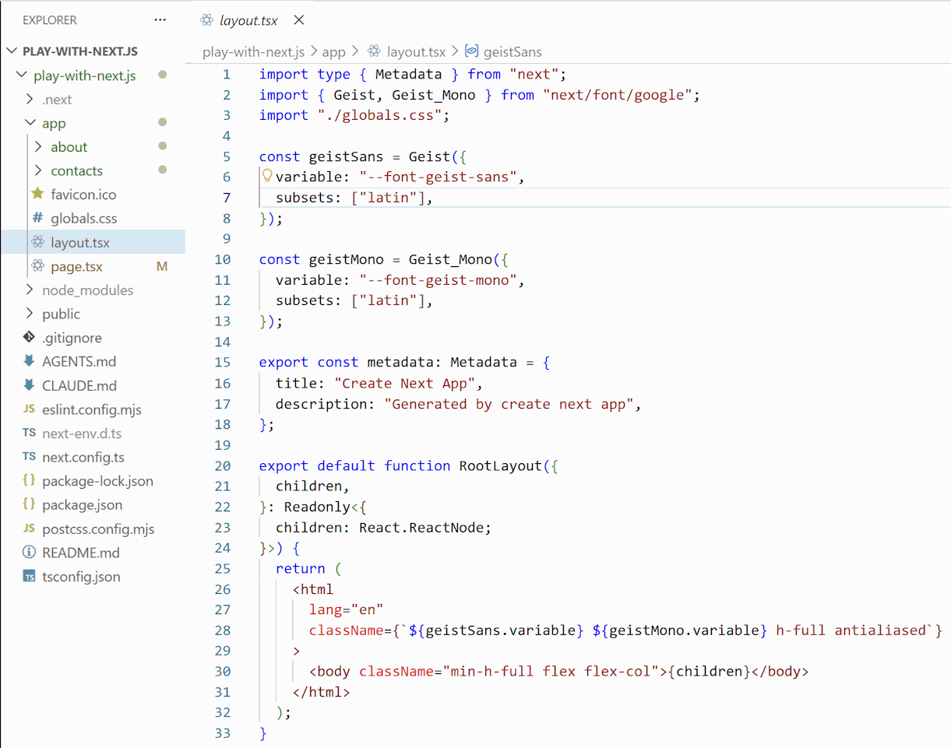

Add the Navigation Component
Add the following component to the original code: `import Link from "next/link";`
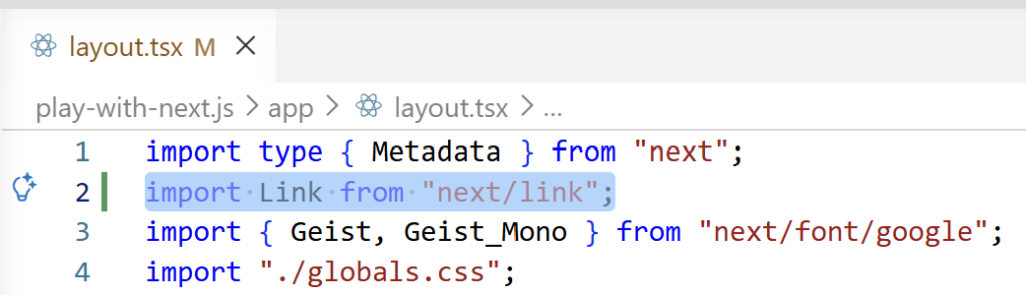

Build the Page Structure
Inside the <body> add the structure of the page content, leaving the ` className="min-h-full flex flex-col"> part`:
<body>
<header>…</header>

<main>
{children}
</main>

<footer>…</footer>
</body>
Here is how it should look in the end:
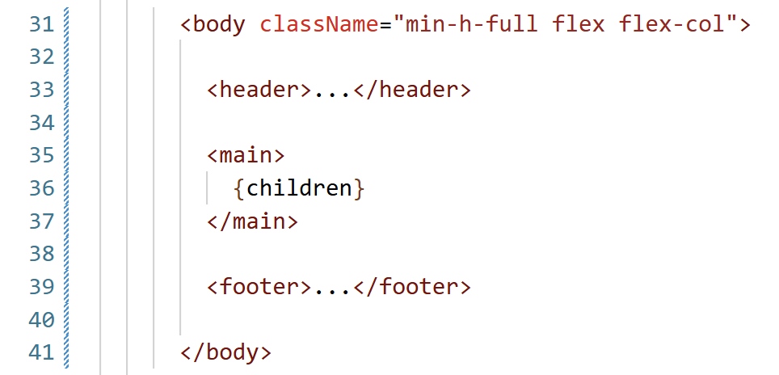

Edit the Header
Paste the navigation bar details inside the <header> section:
<nav>
<Link href="/">Home</Link> |{" "}
<Link href="/about">About</Link> |{" "}
<Link href="/contacts">Contacts</Link>
</nav>
It should look like this:
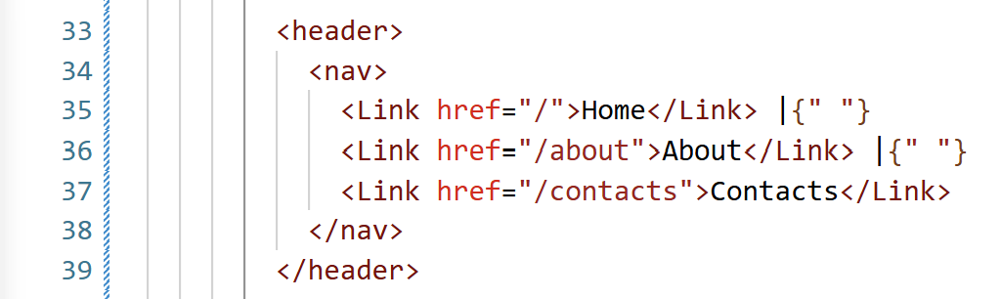

Edit the Footer
Paste this or similar code in the Footer section:
<p>© 2026 My Next.js Site</p>
Here is how it should look:
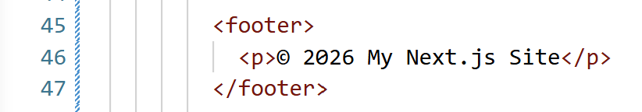

The Result – Layout in VS Code
This is the final content of the layout <body> section:
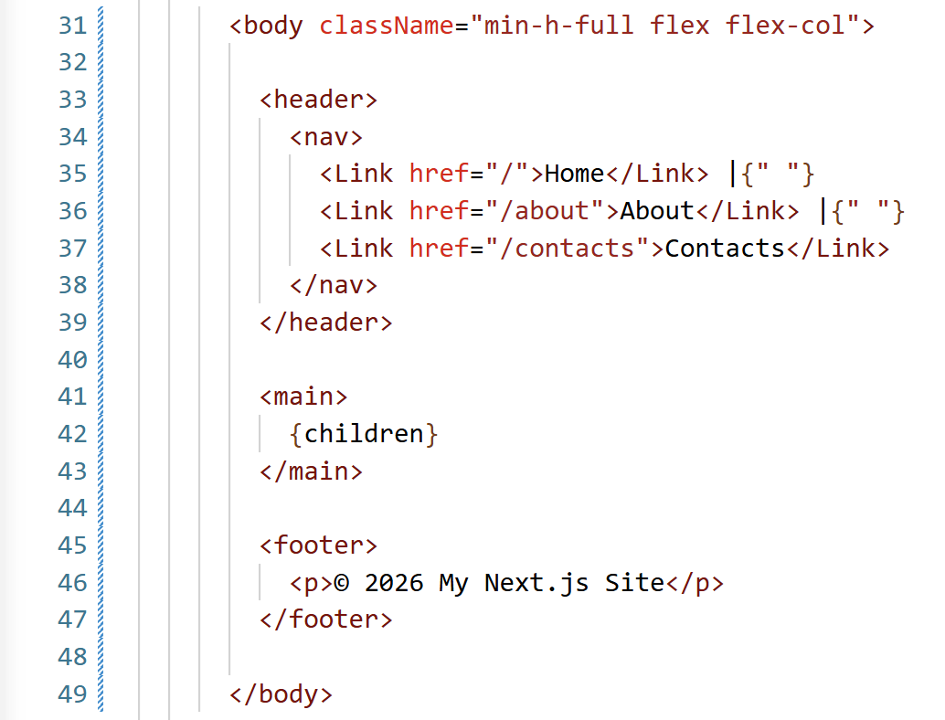

Test the App Navigation
Run the app and test the pages and navigation: https://localhost:3000. The navigation bar should be clickable:
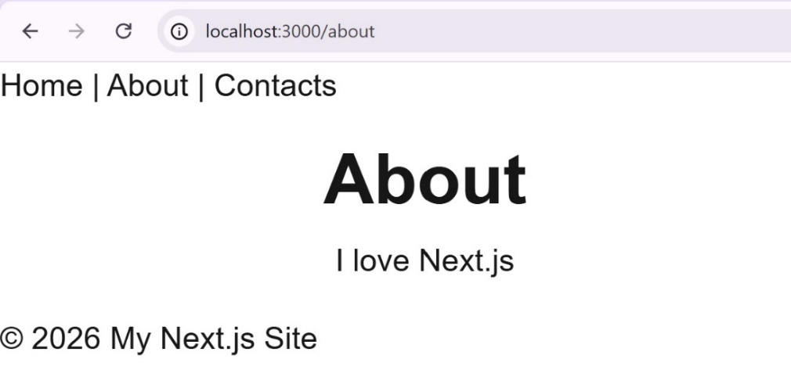

Step 4. Improve Styling (with AI)
Now you are free to use AI. Run a prompt to:
- Style the layout and app pages with Tailwind
- Implement modern, well looking UI

Sample AI Prompt
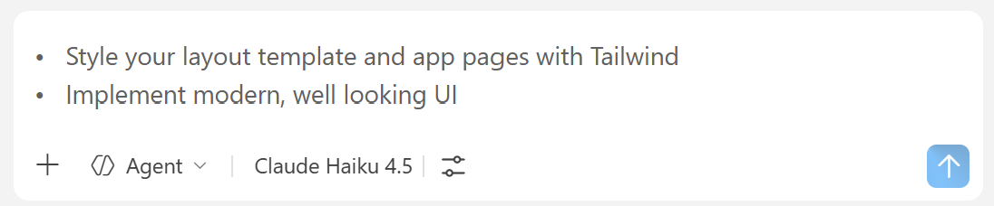

The Result – App in the Browser
This is how the improved app UI may look like.

The Home Page
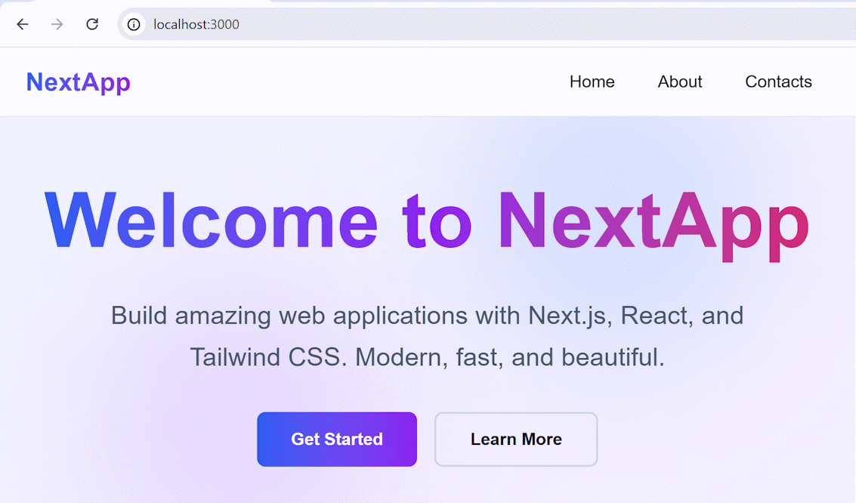

The About Page
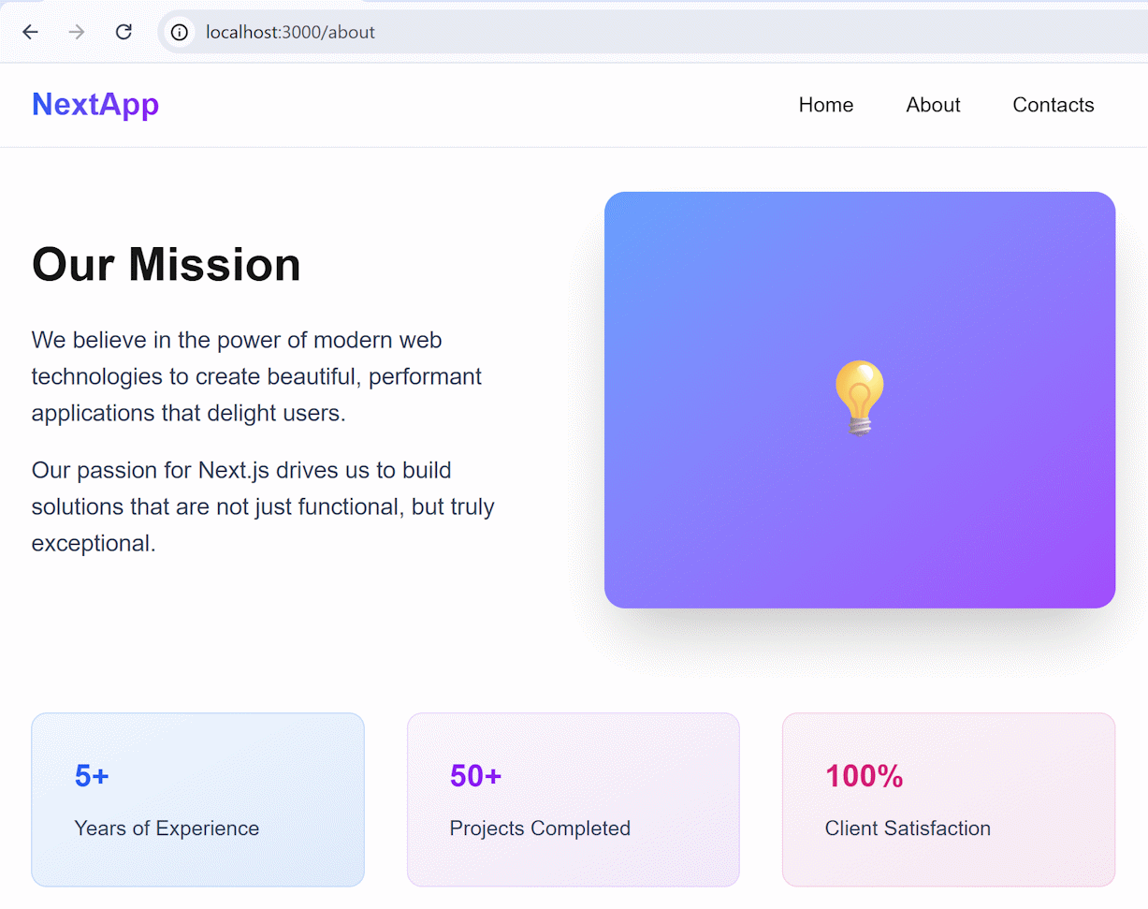

The Contacts Page
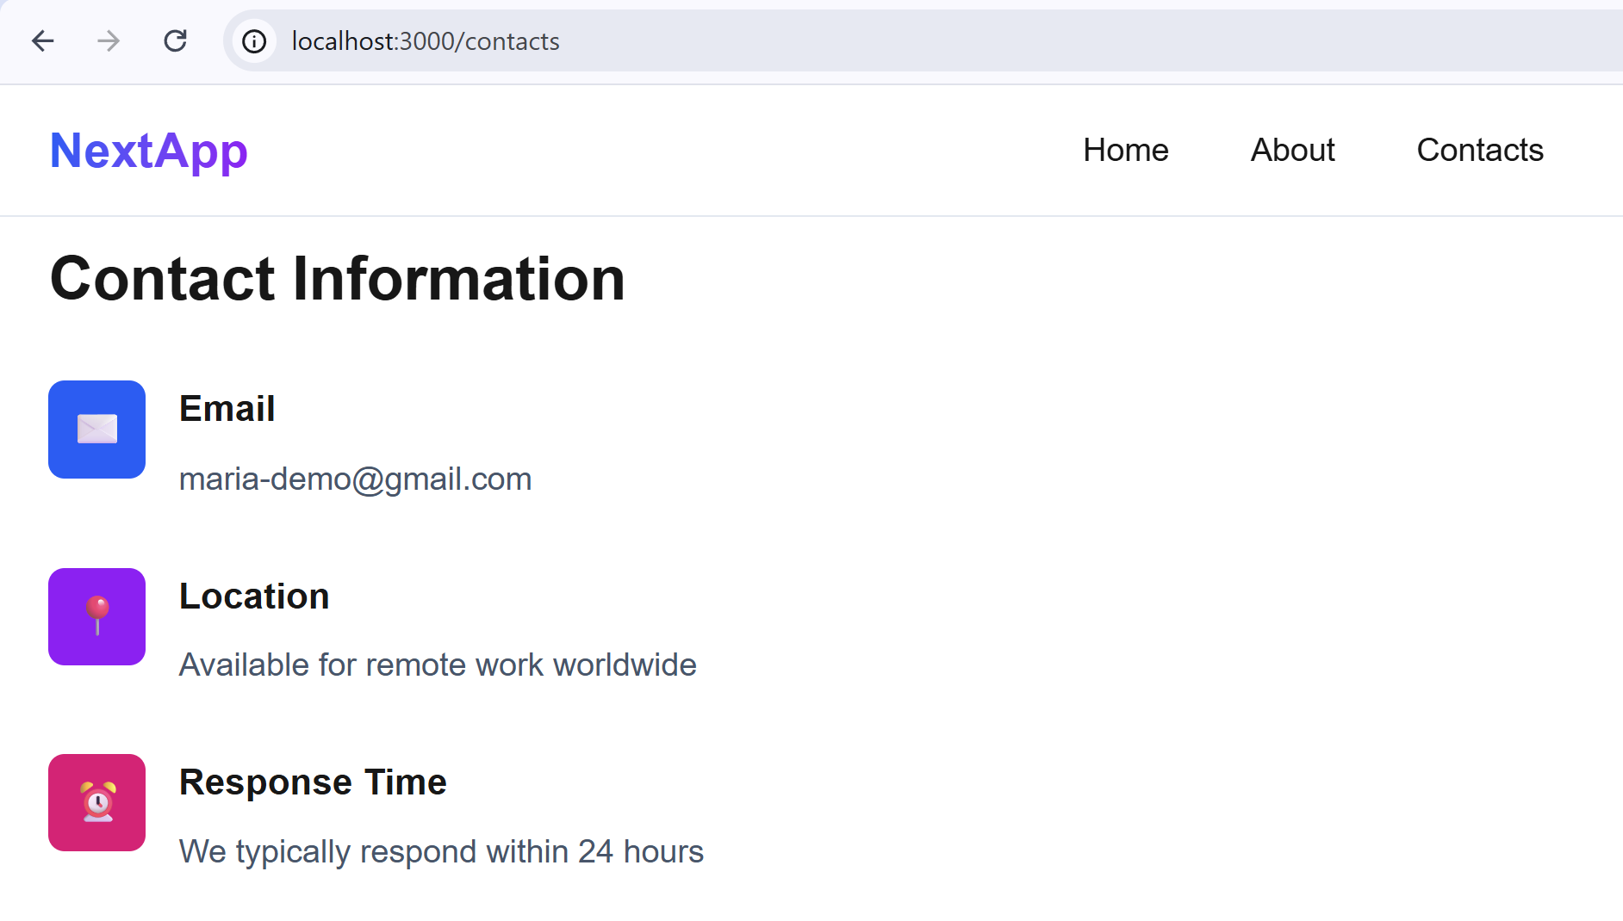

Step 5. Extract Components
As applications grow, we often repeat the same structure or styling in multiple places. For example:
- navigation links
- page titles
- paragraph styling
- buttons
- cards
Instead of copying the same code repeatedly, we can extract it into reusable components.
This gives us several advantages:
- cleaner and shorter code
- consistent styling across the app
- easier maintenance
- better project structure
- reusable UI elements
For example, instead of repeating:
<p className="text-lg text-gray-600">
I love Next.js
</p>
on multiple pages, we can create a reusable `PageContent` component:
<PageContent>
I love Next.js
</PageContent>
The component contains the shared styling, while the page only provides the content through the <children> prop.
You can use AI prompt or extract the components by hand.

Sample AI Prompt
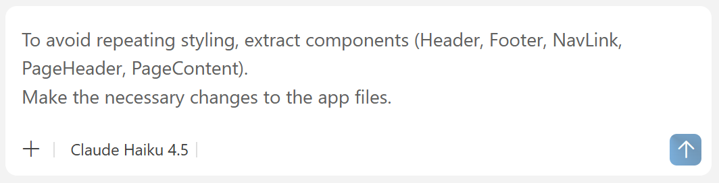

The Result – Extracted Components
There will be the `components` folder with several reusable UI components looking like this:
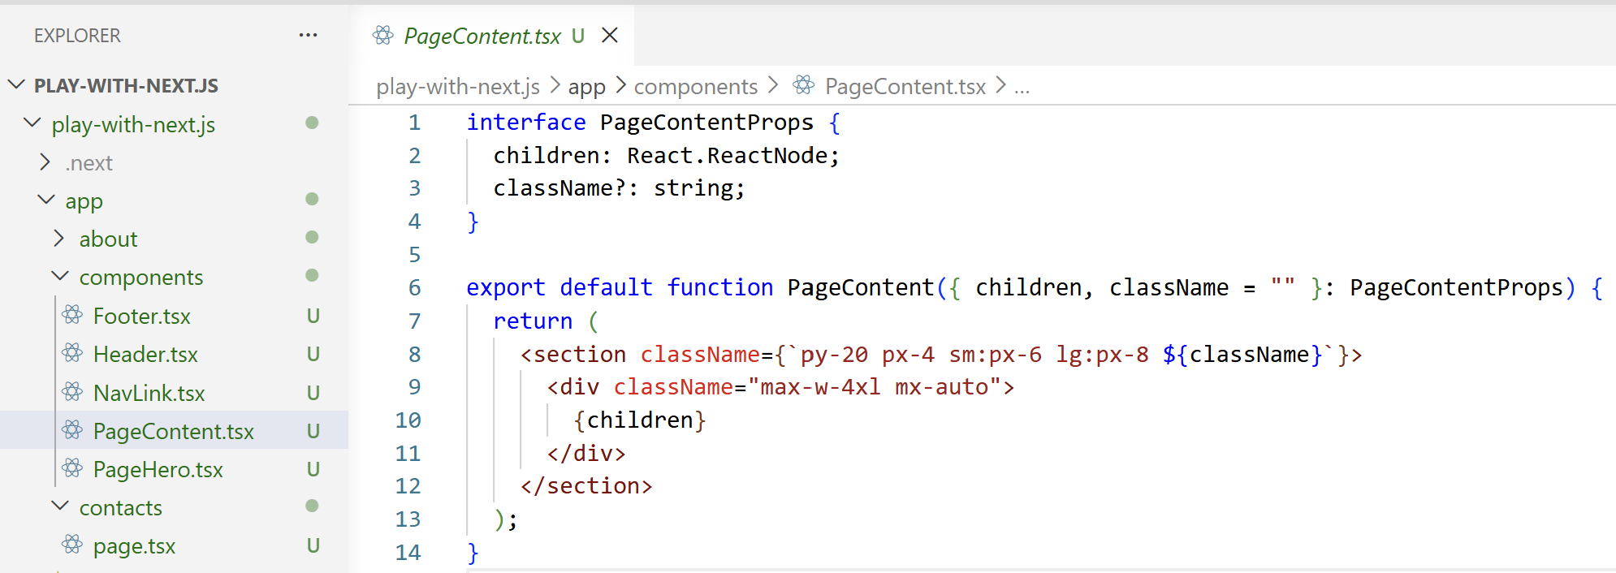
The components will be put on all pages where applicable:
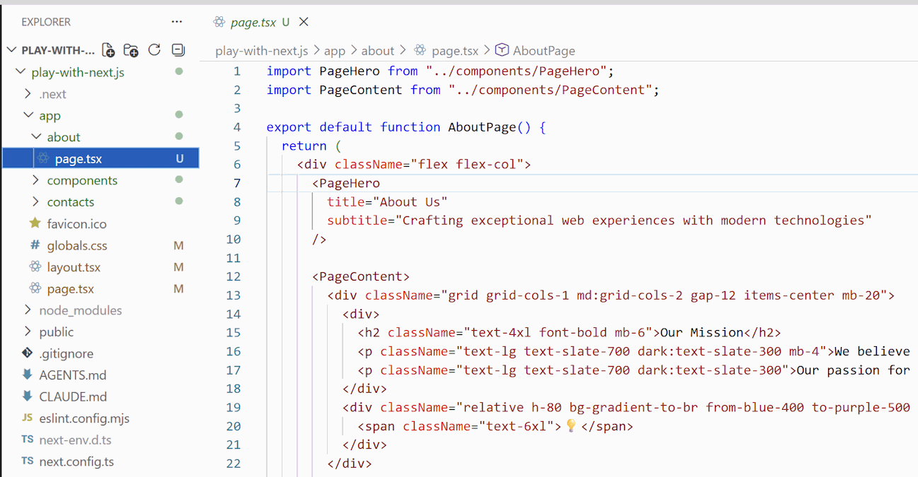

Static Portfolio Website
In this exercise, we shall create a static web site in Next.js:
- Build a personal portfolio as a multi-page static Next.js site.
- Use server components with static rendering (SSG) – no DB, no API calls.
- All content should be hardcoded in a JSON file `site-content.json`, for easier editing.
- Site topic: full-stack software engineer (React, Next.js and related technologies)

Step 1. Setup the Project
Create a new workspace in VS Code, e.g. `portfolio-site`.
Initialize a Next.js project with TypeScript, Tailwind and App Router. Use `npx create-next-app@latest`.

Step 2. Pages and Layout
- Implement the following pages as server components (SSG):
  - `/` – Home: hero section + short intro + links to the other pages
  - `/about` – About: bio, skills, experience
  - `/projects` – Projects: grid of project cards (title, one-line description, screenshot)
  - `/projects/[slug]` – Project Details: full project info (one page per project)
  - `/contact` – Contact: contact info
  - Implement shared layout `app/layout.tsx`: navbar + footer on all pages
  - Use `generateStaticParams()` for the project detail pages (pre-render at build time)
  - Use `generateMetadata()` to set page title, description and OpenGraph tags per page

Sample AI Prompt
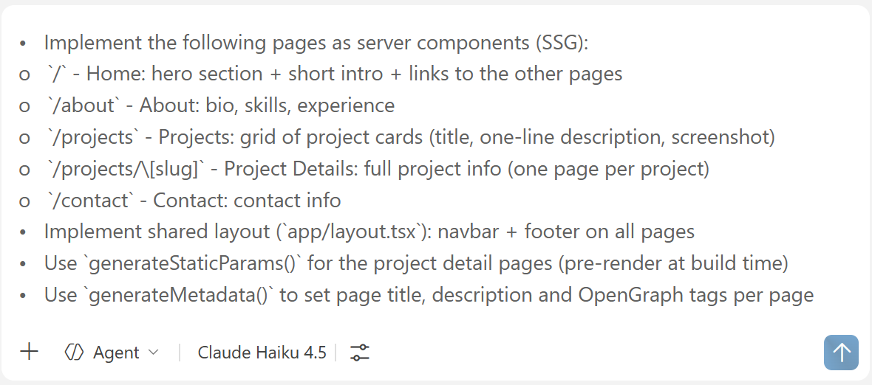

Step 3. Styling and Performance
- Style everything with Tailwind (no custom CSS)
- Use `<Link>` for navigation between pages (with prefetch)
- Use `<Image>` for all photos and project screenshots (WebP + lazy loading)
- Implement responsive design: mobile-first layout, desktop breakpoints
- Implement modern design: with custom fonts, icons, transitions, effects

Sample AI Prompt
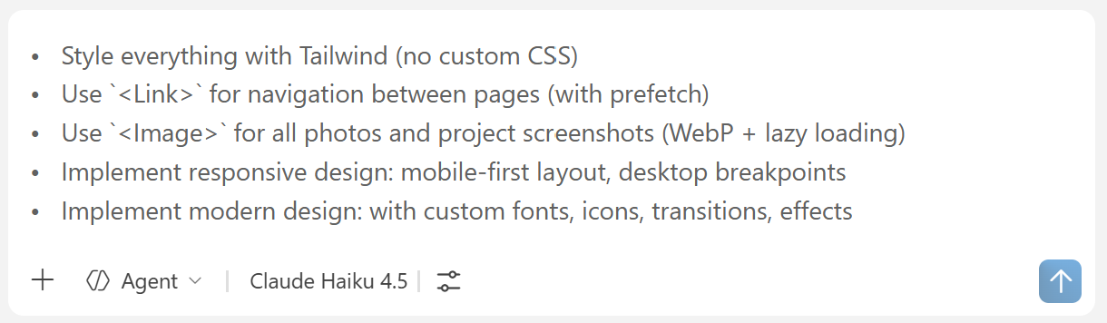

The Result – Portfolio App in the Browser

The Home Page
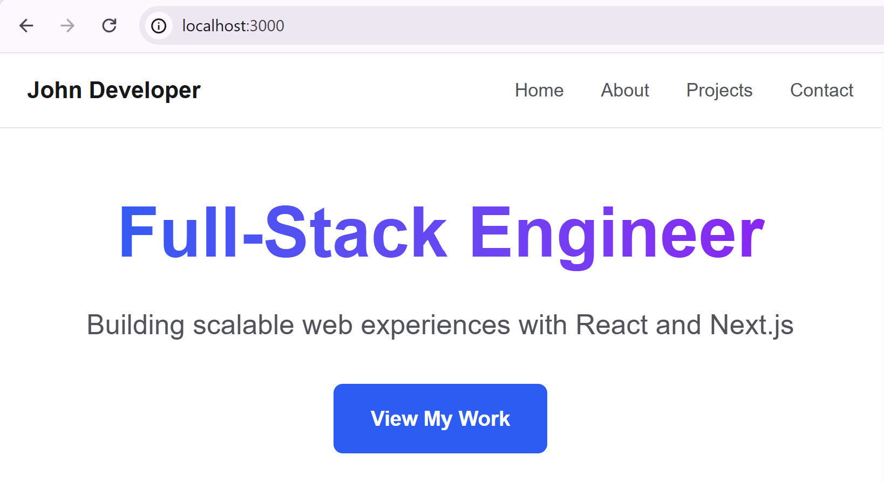

The Projects Page
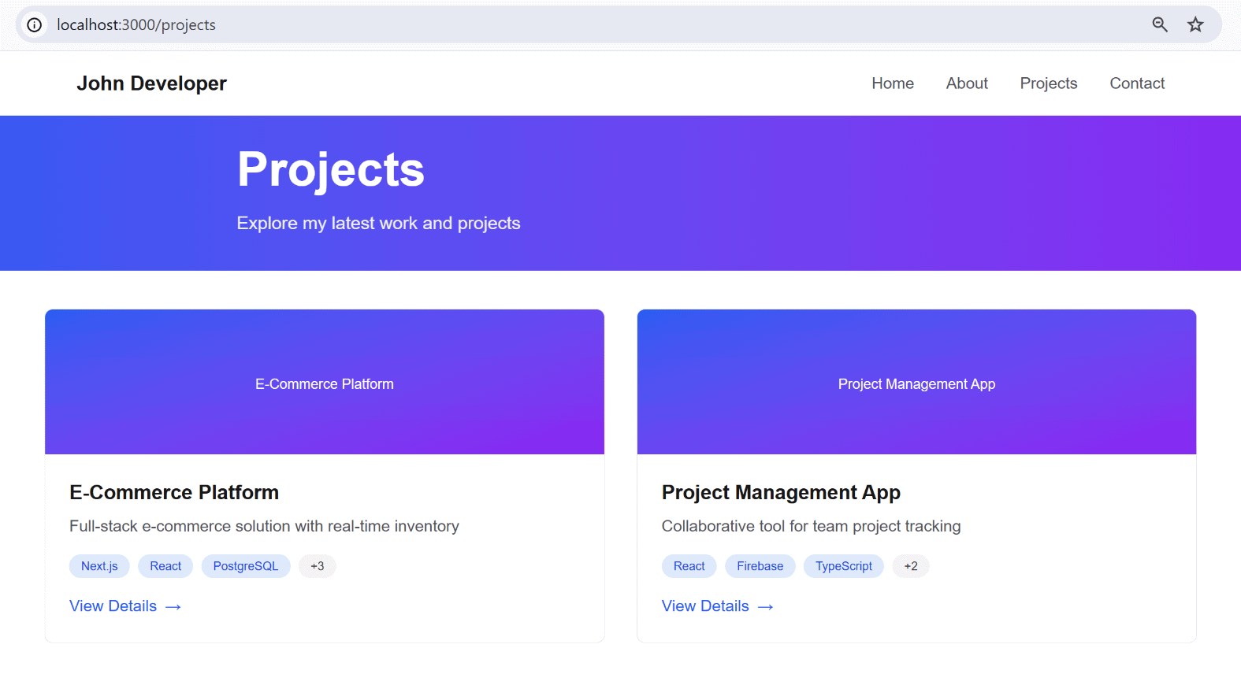

Step 4. Verify SSG
- Run `npm run build` and check that all pages are pre-rendered as static HTML.
- Open the deployed app and verify: [View Page Source] shows the full content (SEO-friendly)

Check the Static HTML
In the terminal, run `npm run build`. After the building finishes, you should see output like:
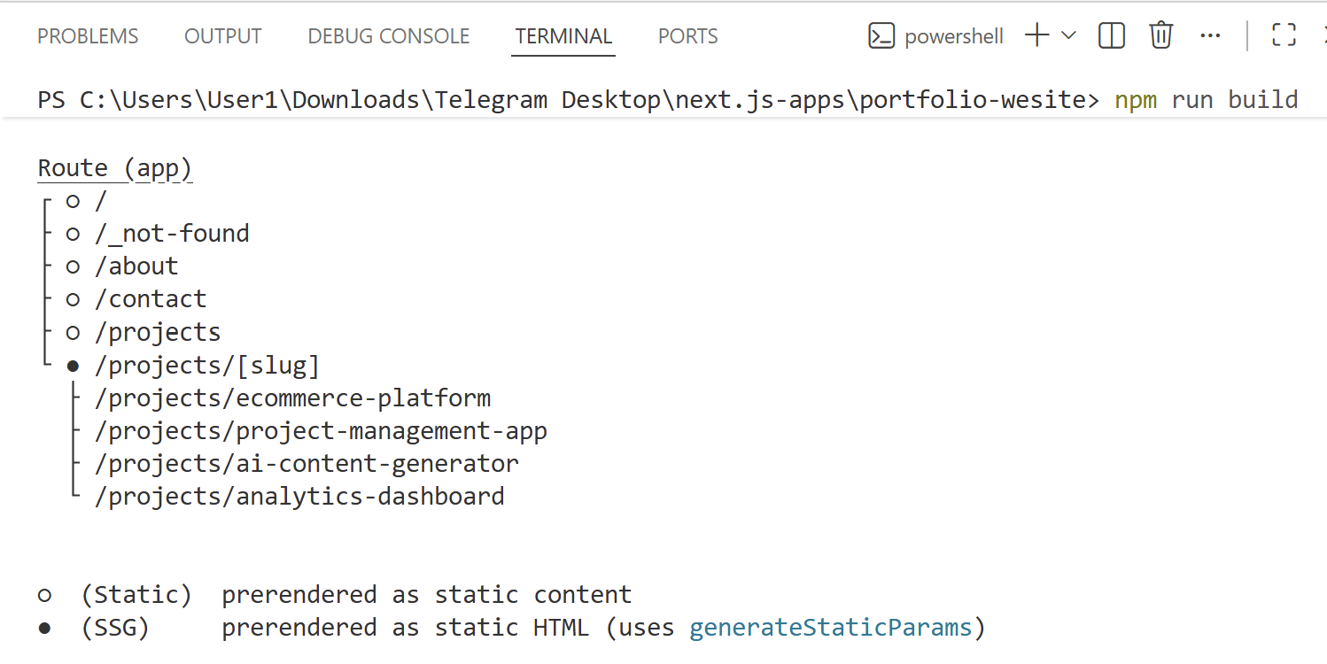

View Page Source
Start the production server with `npm run start` and click the link which will appear (e.g. http://localhost:3000). Then open any page, right click and select [View Page Source]:
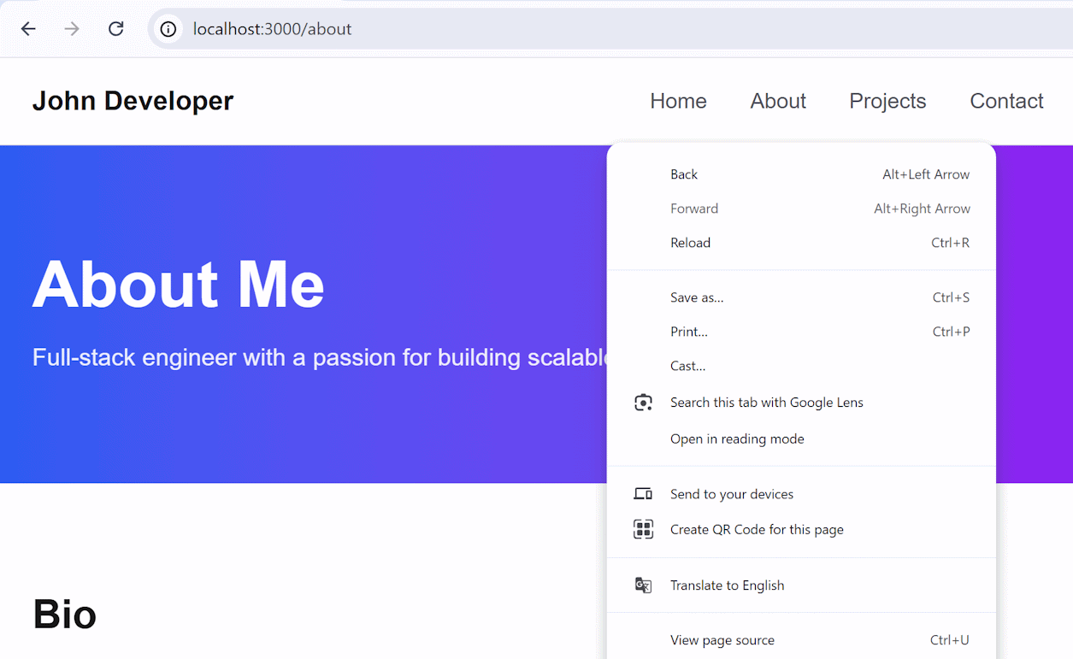
You should see a result like this:
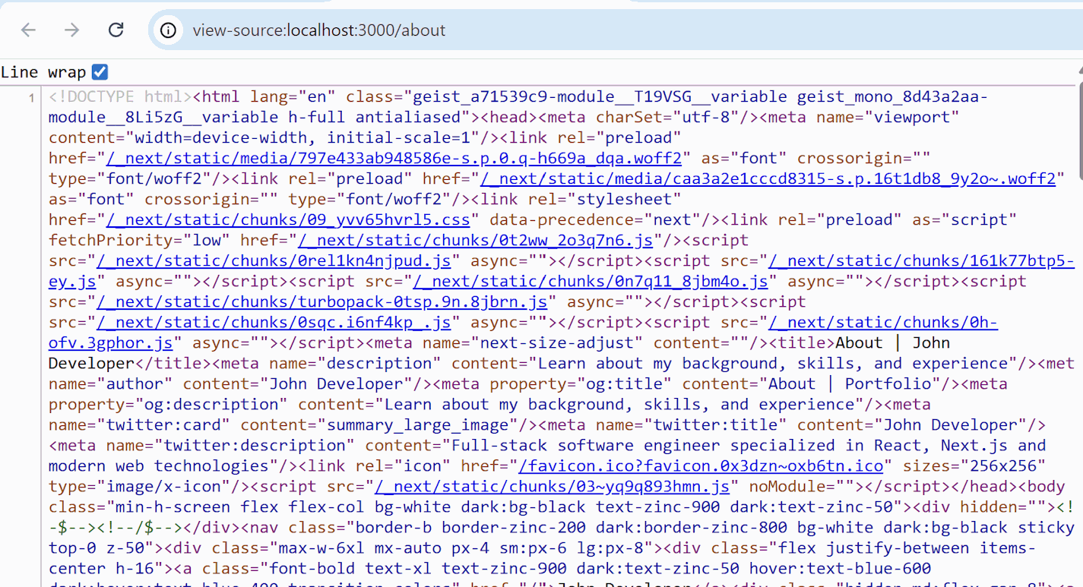
The HTML content already exists inside the HTML before JavaScript runs. This proves the page was statically generated (at build time).

Product Shopping Cart
In this exercise we shall build a product listing site with shopping cart, using React server and client components in Next.js. The goal is to illustrate where to use server-rendered components and where to use client-rendered components in Next.js.
Step 1. Setup a Project
Create a new workspace in VS Code, e.g. `product-cart`.
Initialize a Next.js project with TypeScript, Tailwind and App Router: `npx create-next-app@latest`.

Step 2. Data Layer
- Implement a data layer for the app: /lib/app-data.ts (list all products, find product by slug)
- Products should have: title, photo, slug, description, isFeatured

Sample AI Prompt
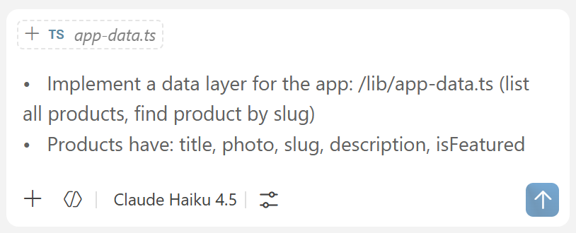

The Result – Data Layer
In the filles there will be a TypeScript file with sample products:
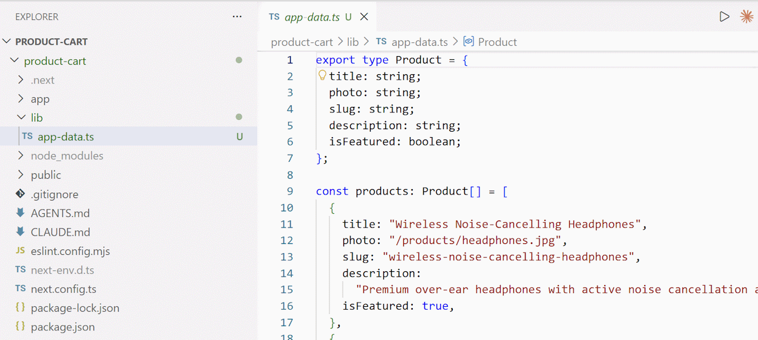

Step 3. Product Pages
- Implement app pages as server components:
  - `/` – Home: show featured products + [View Products] button
  - `/products` – Products list (with server-side paging)
  - `/products/[slug]` – Product Details: full product info
- Implement shared layout `app/layout.tsx`: navbar + footer on all pages
- Implement clean, well-looking UI, with responsive design
To render products, a Next.js app typically uses dynamic server components. Products should be rendered at the server side to improve SEO and site load speed. Products page is dynamic (SSR), because typically products come from the database and may change anytime. We shall not use cache for the product pages, because it may render outdated data.

Sample AI Prompt
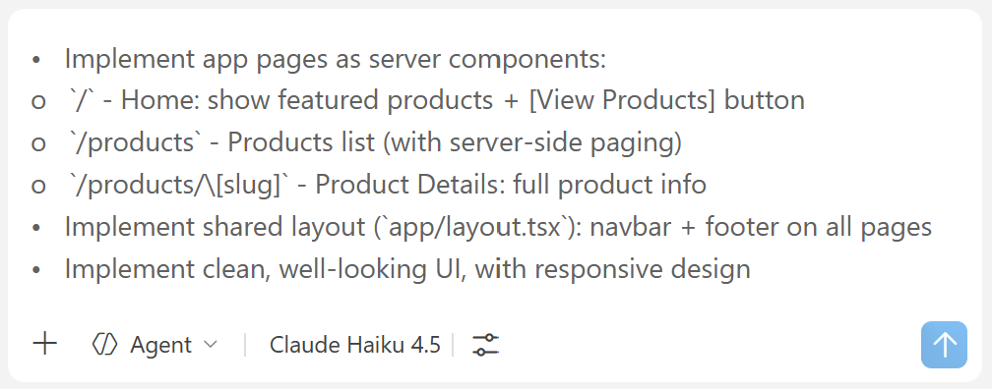

The Result – Product Pages
This is how the Home page, the Products page and the Product Details page may look like.

The Home Page
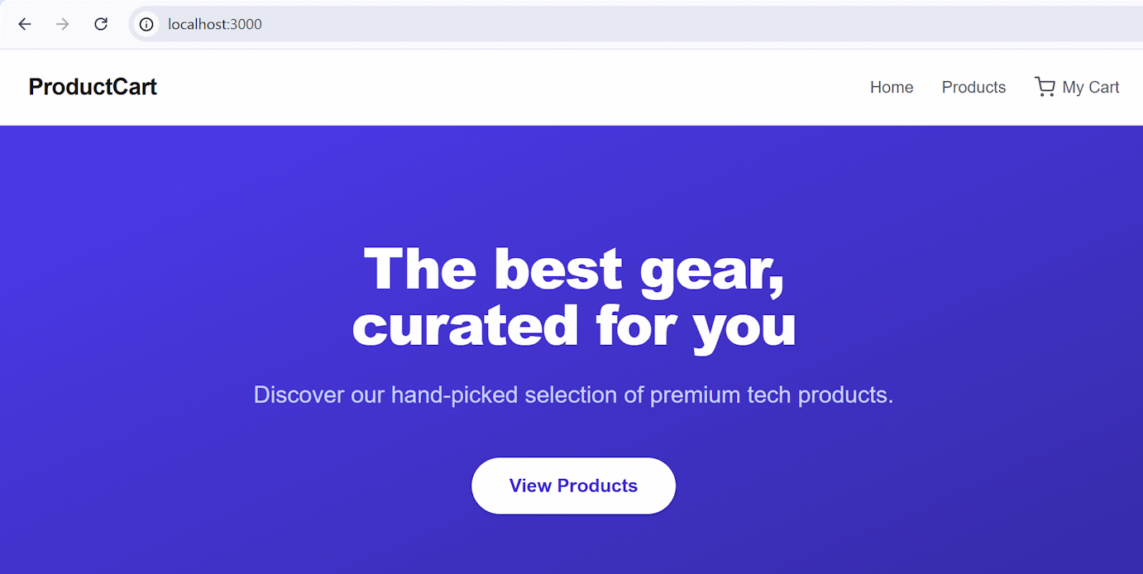

The Featured Products
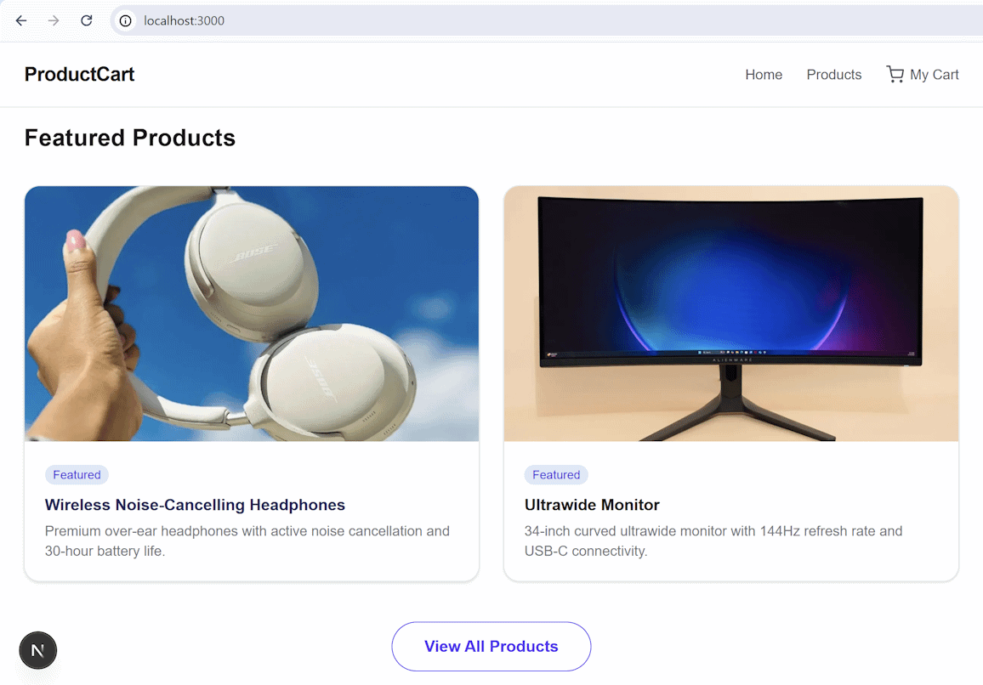

Product Cards
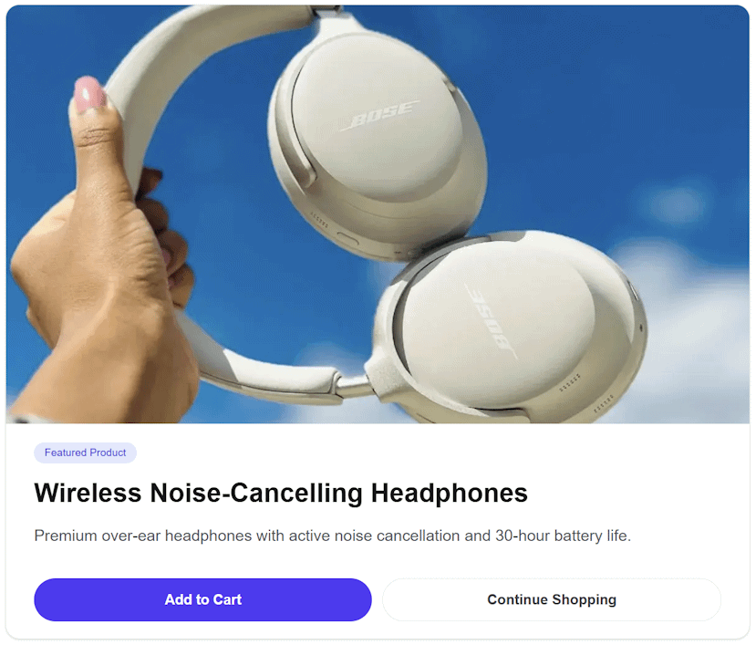

Step 4. Shopping Cart
Implement a shopping cart:
- Implement [Add to Cart] button for the products
- Keep the cart content in localStorage
- Implement a server-rendered page "Shopping Cart": /cart
- Implement view / edit / delete cart content
- Use client components where relevant, e.g. AddToCart, CartContent
- Add [My Cart] link to the navbar (link to the "Shopping Cart" page)

Sample AI Prompt
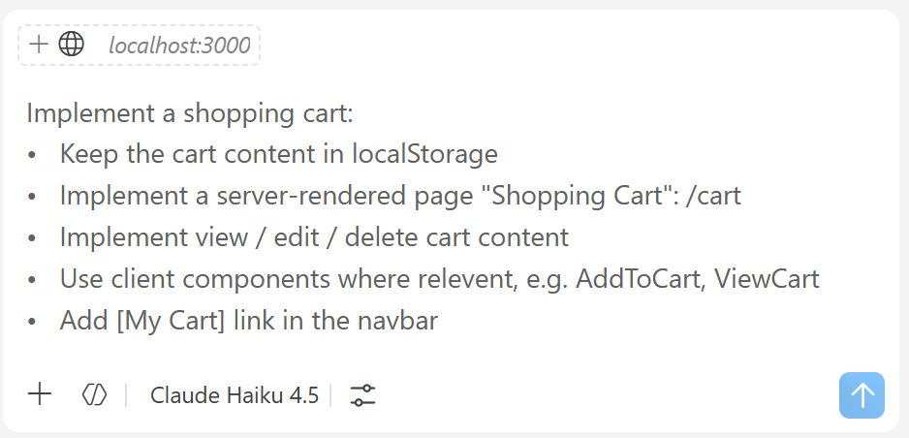

The Result – Shopping Cart
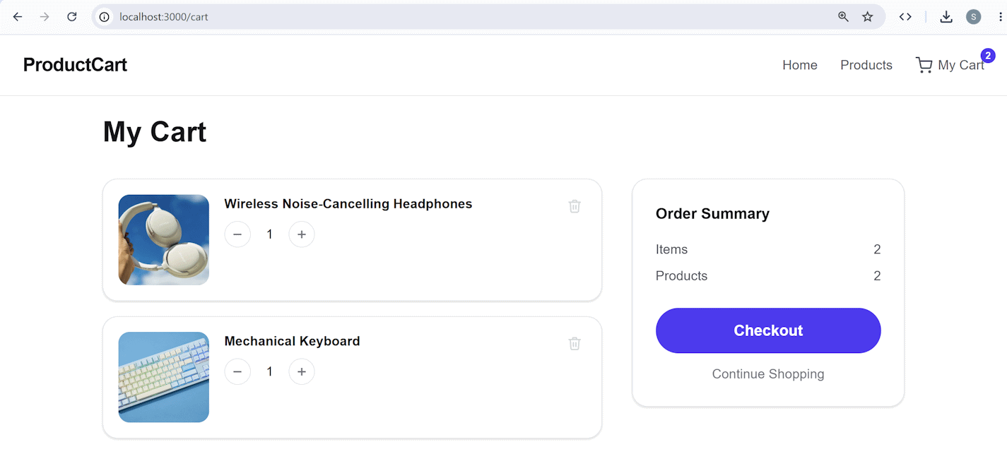
Note that some components will be server-side rendered (e.g. the Shopping cart page) and some will be client-side rendered, because they need interaction with the browser local storage, where the cart contents is stored.

Step 5. Dynamic Rendering for Products
Configure rendering mode for the app routes:
    - Cached Rendering (ISR) for the Home page (revalidates every 5 minutes)
    - Dynamic Rendering (SSR) for all products pages: /products/*
    - Static rendering (SSG) for the cart page: /cart
Note that the shopping cart page holds dynamic content, but it should be static, because the page content from a server perspective is static: it holds the card component HTML + JS code. The dynamic content (cart items) is rendered client-side in React component in the browser.

Sample AI Prompt
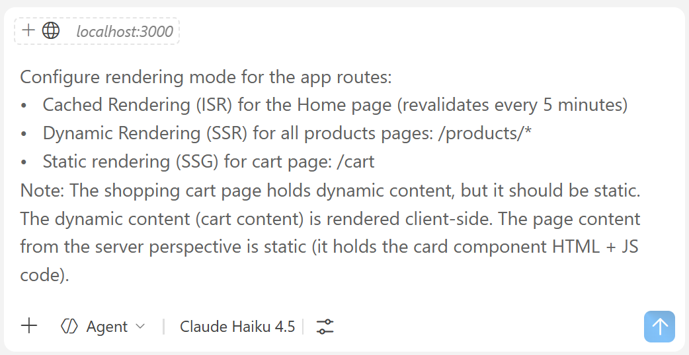

The Result – Rendering Modes
Check the output after running the `npm run build` command to see the rendering mode for each route:
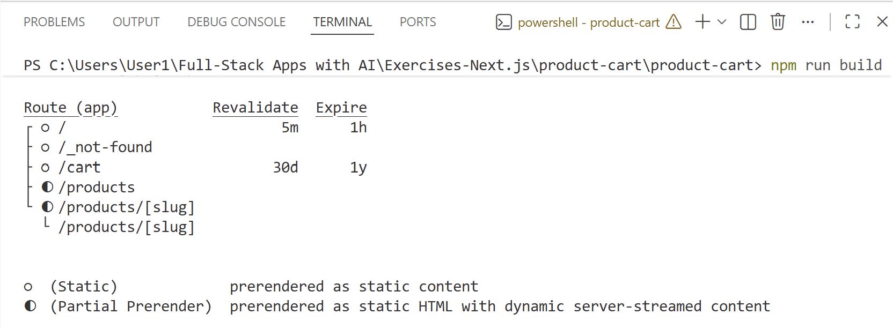

Weather Dashboard
Build a weather forecast dashboard with Next.js using the Open-Meteo API (https://open-meteo.com):

Step 1. Setup the Project
Create a new workspace in VS Code, e.g. `weather-dashboard`.
Initialize a Next.js project with TypeScript, Tailwind and App Router: `npx create-next-app@latest`.

Step 2. App Pages
Build app pages:
- `/` (home page) – server component, ISR cached rendering (revalidate every 5 minutes)
  - Show weather for a fixed set of 5-6 popular cities (Sofia, London, New York, Tokyo, Sydney, ...)
  - Fetch data from Open-Meteo server-side
- `/city/[name]` (city details) – server component, dynamic rendering (SSR)
  - Show current weather + 7-day forecast for the given city
  - Use `generateMetadata()` for SEO
- `/search` – static page (SSG) + client component
  - Search box to find a city by name, then navigate to `/city/[name]`

Sample AI Prompt
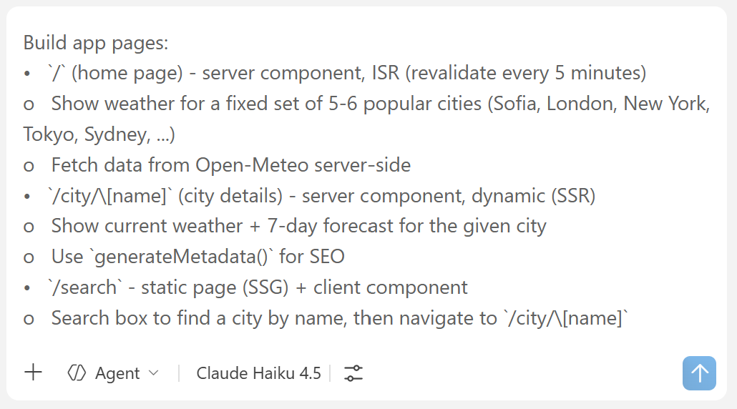

The App in the Browser

The Home Page
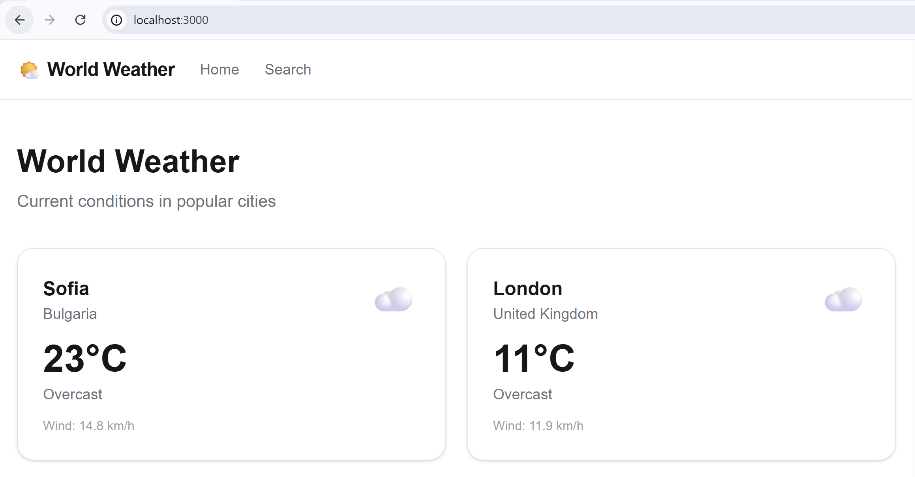

The City Weather Cards
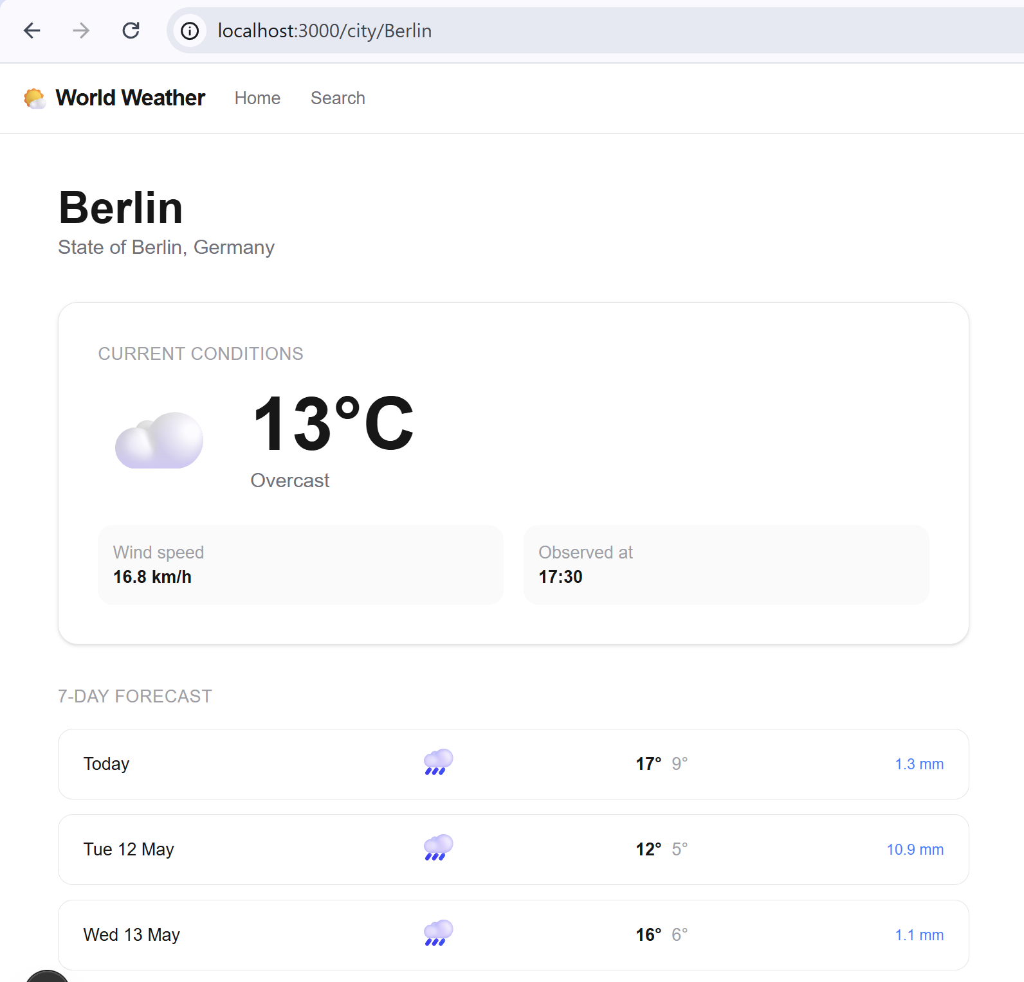

Step 3. Suspense and Streaming
- Add `loading.tsx` at route level for a loading skeleton
- Wrap each city's weather card in <Suspense fallback={<WeatherSkeleton />}>
- Each card renders independently as data arrives (streaming)

The Result – Loading Component
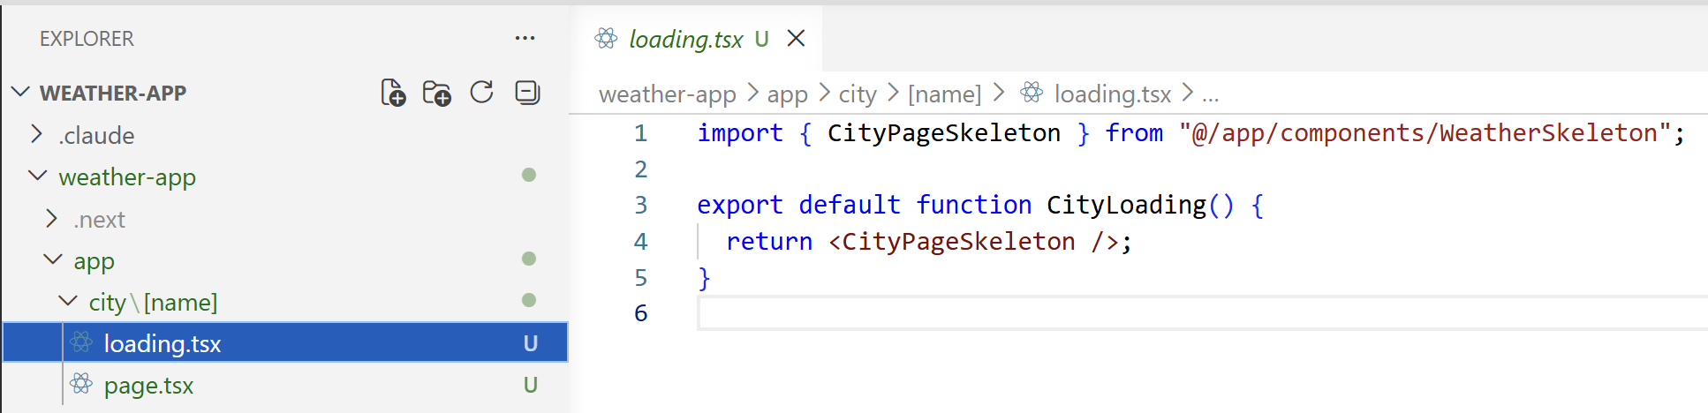

Notes App
In this exercise we shall build a Next.js app with server-side rendering and server actions:
- Build a single-user "Notes" app with Next.js + Neon + Drizzle (no auth, simpler to start)
- Server components read the DB directly; server actions handle all mutations (no API)

Step 1. Setup the Project
Create a new workspace in VS Code, e.g. `notes-app`.
Initialize a Next.js project with TypeScript, Tailwind and App Router: `npx create-next-app@latest`.

Step 2. Create a Neon DB
Create a new project and name it properly – e.g. `NotesDB`:
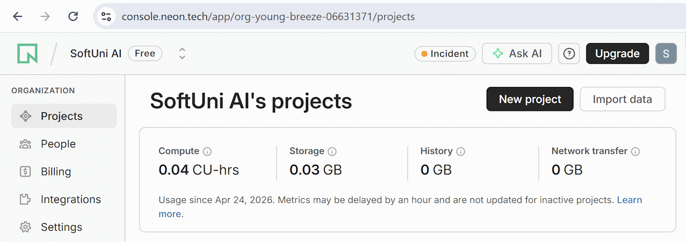

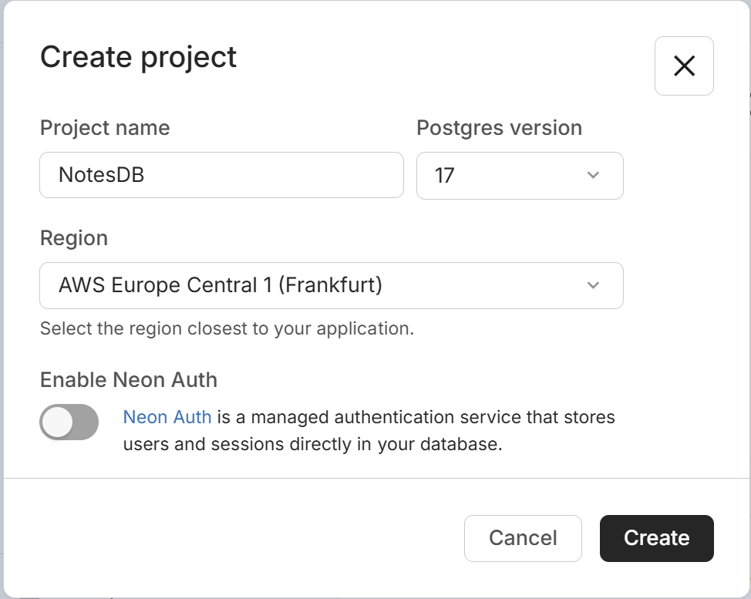

Step 3. Connect Neon MCP
Optionally, connect Neon MCP. This step is not required!
Open the [Extensions] section in VS Code and type `@mcp neon` in the search bar. Select [Install in Workspace]:
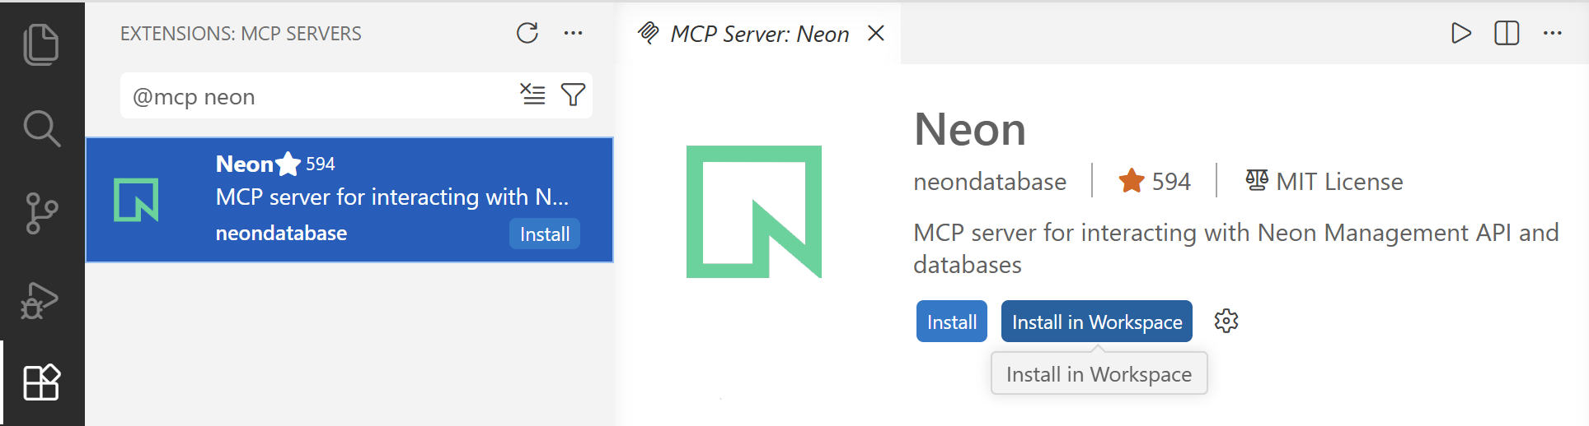
Then allow authorization of the MCP to your Neon account:
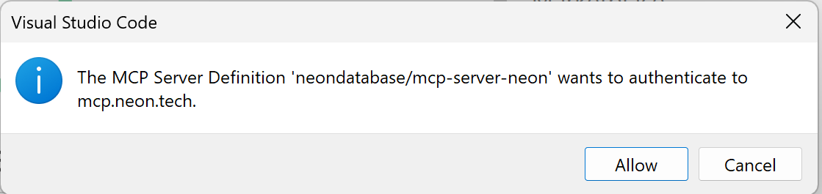
And open the link:
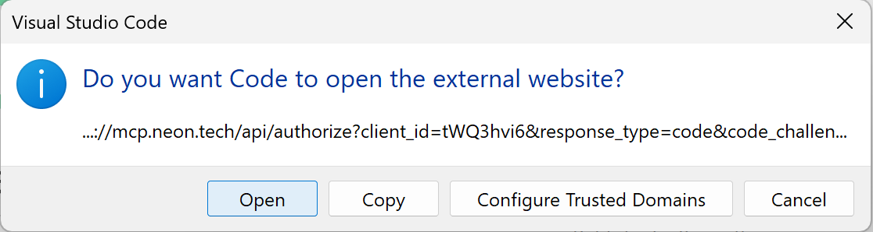
Add the Neon database name in `AGENTS.md` to avoid ambiguity when using Neon MCP. Use the following code:
# Neon MCP Database Access Rules:
- Connect Neon MCP only to a database project named `NotesDB` in my Neon account.
Test the MCP server. Run `Show DB info` in the AI Chat:
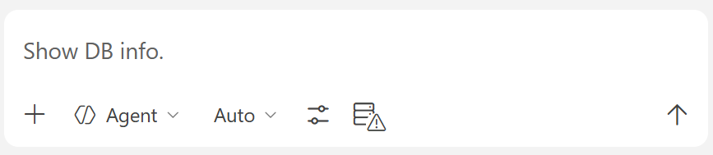
You should get some details about the Notes database:
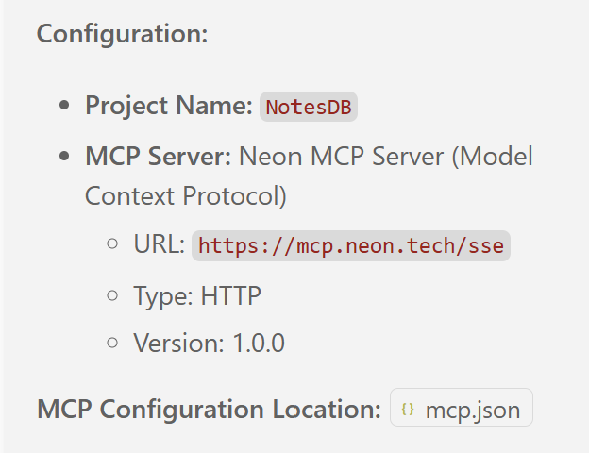
If the MCP is not properly configured, it will either not work or will ask you which Neon project to use (because Neon MCP is connected to your entire account with all your projects, no to a specific project).

Step 4. Configure Neon DB Connection
Configure Neon DB connection in your Node.js project (use Neon MCP):
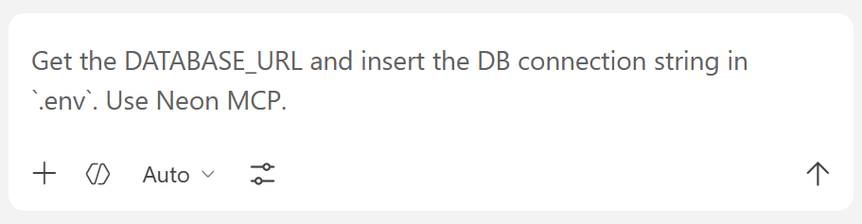
The goal is to have your database connection string properly configured in your project's `.env` file.

Step 5. Initialize Database
Define the database schema using Drizzle ORM:
- notes table:
  - id
  - title
  - content (text)
  - tags (text[])
  - created_at
  - updated_at
- Install the required npm packages:
  - Drizzle ORM
  - Neon database driver
  - Drizzle Kit
- Configure Drizzle and create the initial database migration
- Generate and apply the generated migration:
  - npm run db:generate
  - npm run db:migrate
Seed the database with sample data:
- create 5–8 sample notes
- use different tags for filtering and testing
- implement a seed script: npm run db:seed

Sample AI Prompt
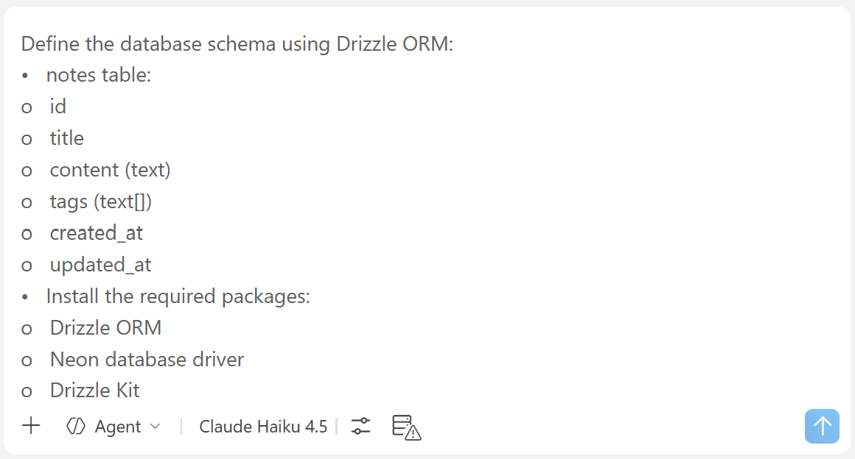

The Table in DB
When the DB schema is created, the DB migration is generated and applied in the DB, and the seed script is run successfully, you should see data rows like these in Neon DB:
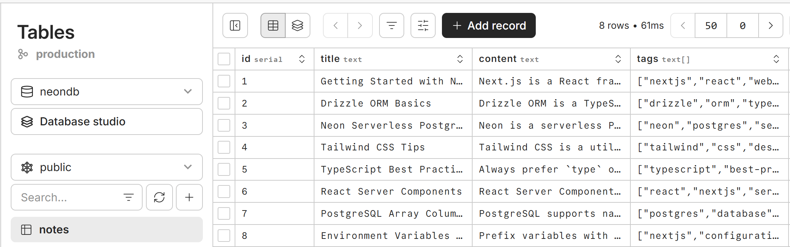

Step 4. App Pages
Implement app functionality: list / view / add / edit / delete notes
- `/` – List All Notes page (server component)
  - Load notes from DB and display as cards, with server-side paging
  - Add [New Note], [Edit], [Delete] links for notes
  - Implement search by keyword and filter by tag (via searchParams: `?search=…\&tag=…`)
- `/notes/[id]` – View Note page (server component)
  - Display full note content + [Edit] / [Delete] links
- `/notes/new` – Create Note (server page + client component form + server action)
- `/notes/[id]/edit` – Edit Note (server page + client component form + server action)
- `/notes/[id]/delete` – Delete Note (server page + client delete confirm component + server action)
- Server actions:
  - `createNote(formData)` – insert into DB, `revalidatePath('/')`, redirect to `/`
  - `updateNote(id, formData)` – update in DB, `revalidatePath('/')` and `revalidatePath('/notes/[id]')`
  - `deleteNote(id)` – delete from DB, `revalidatePath('/')`, `revalidatePath('/notes/[id]')` redirect to `/`
- Database:
  - Use the Drizzle API to implement all DB access logic
- User interface (UI):
  - Style with Tailwind (cards, buttons, forms)
  - Implement a shared layout with header + navbar + footer
Notes about the app structure: the "gold standard" for performance and SEO in Next.js is defaulting to Server Components and only using Client Components for interactive islands that trigger Server Actions. In this app we keep all rendering server-side and use client components where interactivity is needed (e.g. forms).

Sample AI Prompt
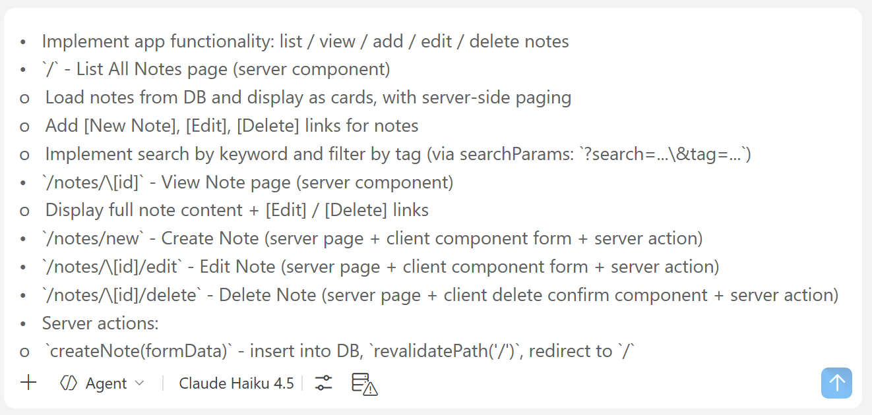

The Result – Notes App
This is how the "Notes" app may look like when ready.

The Home Page
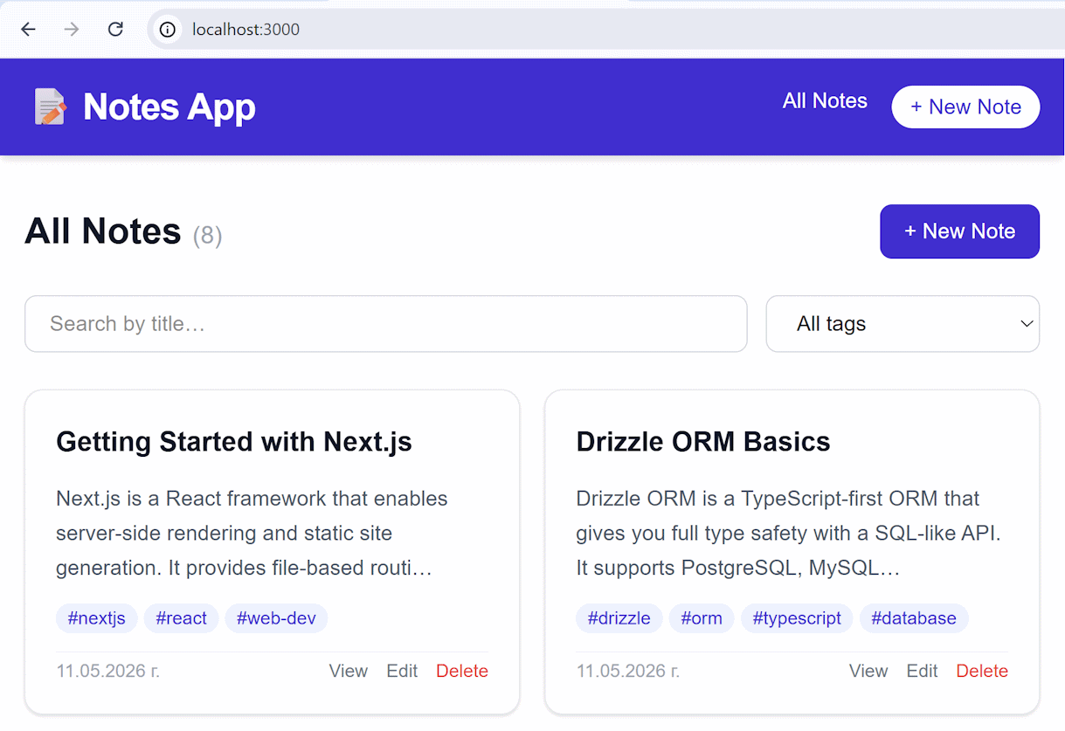

A Note Outlook
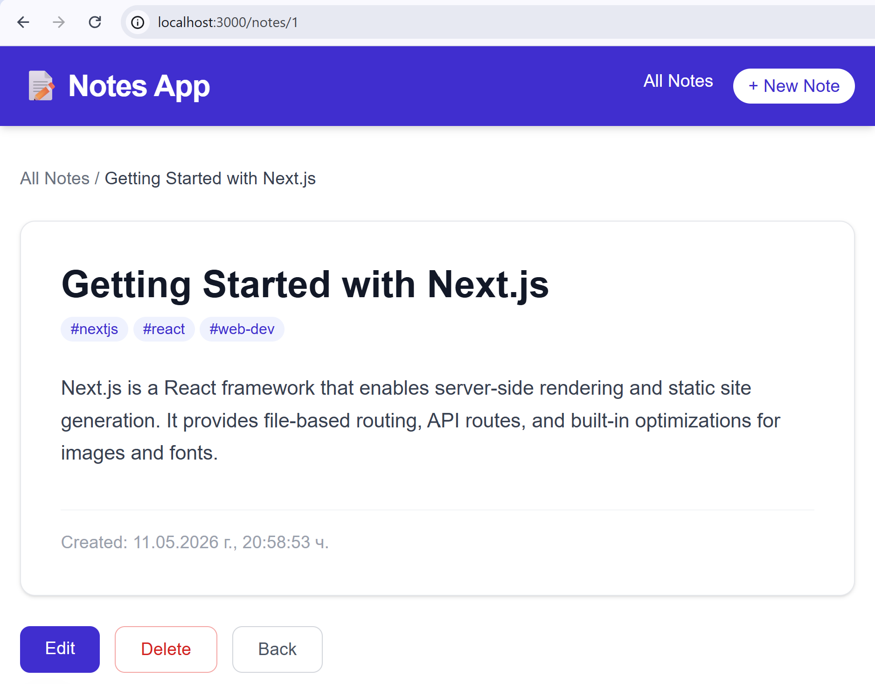

Notes App with Users
Implement users in the Notes app:
- Modify and migrate the DB with Drizzle:
  - Add table: users (email, passwordHash)
  - Add relationship: users have notes
- Implement users (register, login, logout)
  - Use standard auth practices with cookies and JWT
  - Generate a random JWT_SECRET in `.env`
  - Keep user passwords hashed with `bcrypt`
- Implement pages (server-rendered): (auth)/login, (auth)/register, (auth)/logout
  - Implement the interactive forms as client components
  - Implement server-side logic as Server Actions
- Show the currently logged-in user in the site header
- Protect all routes except auth to require logged-in users

Sample AI Prompt
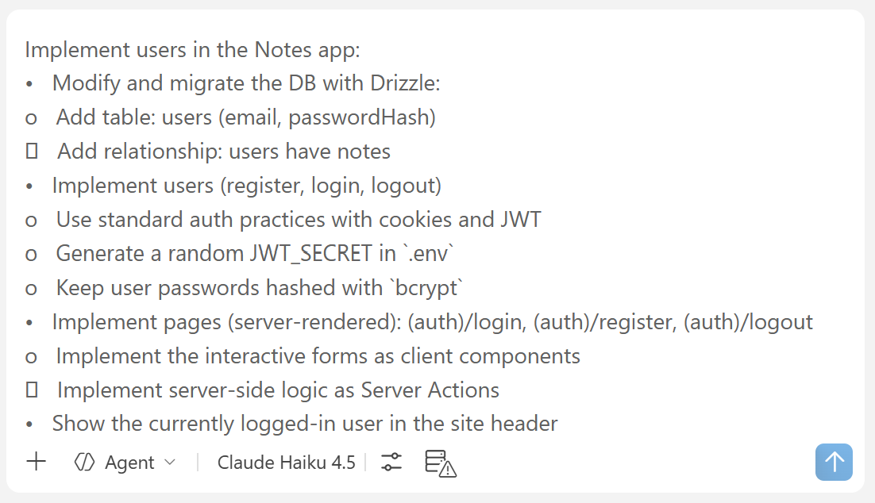

The Database
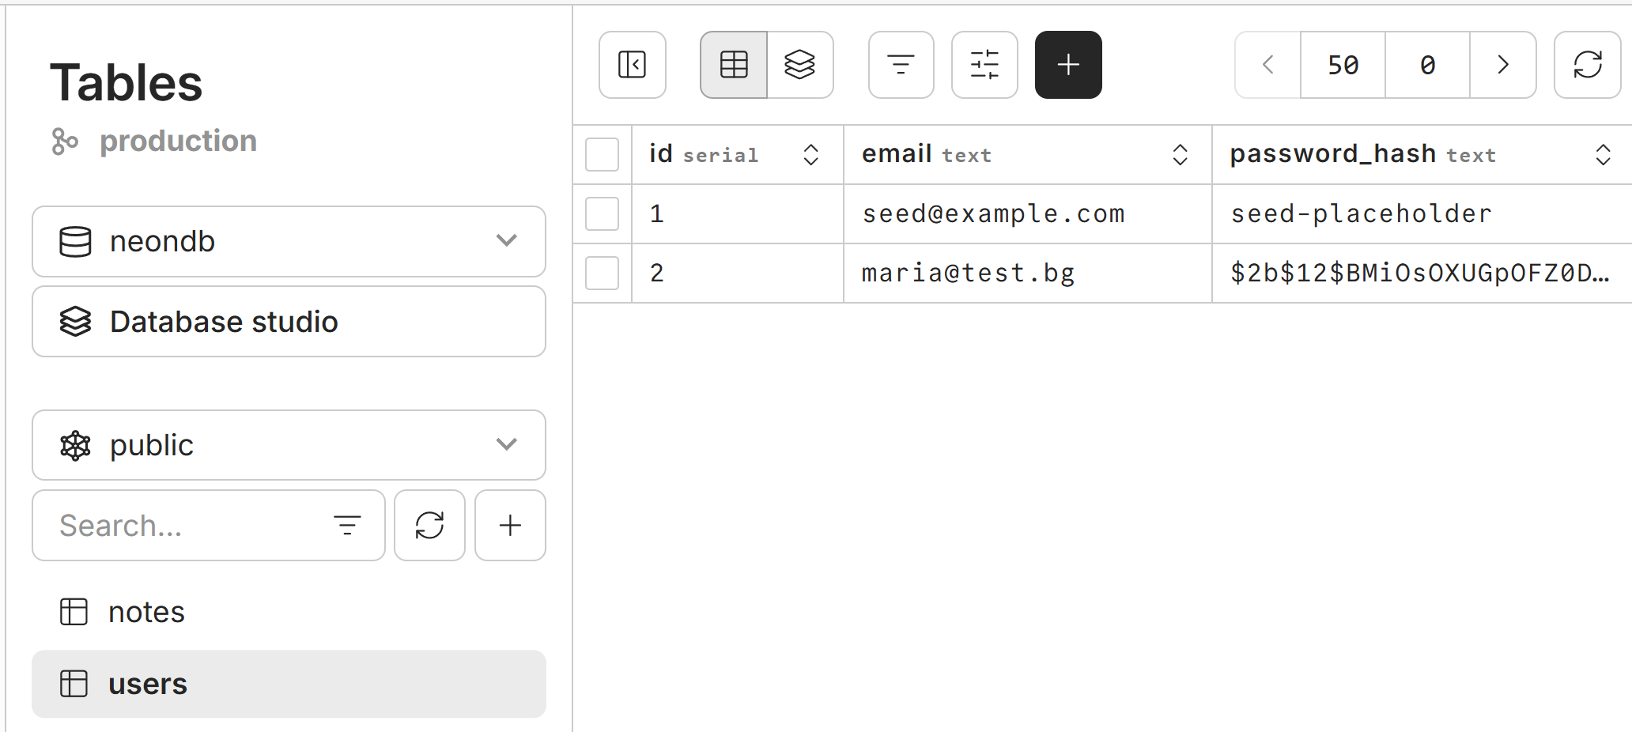

The Result – Notes with Users App

Log In/ Register
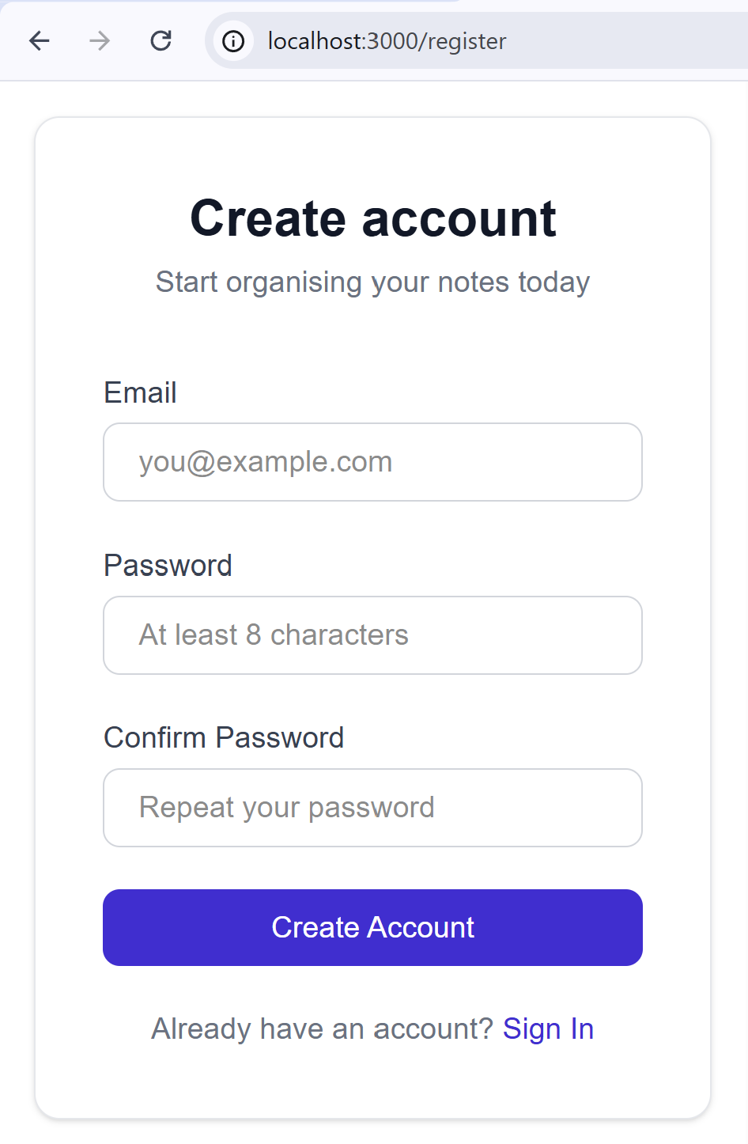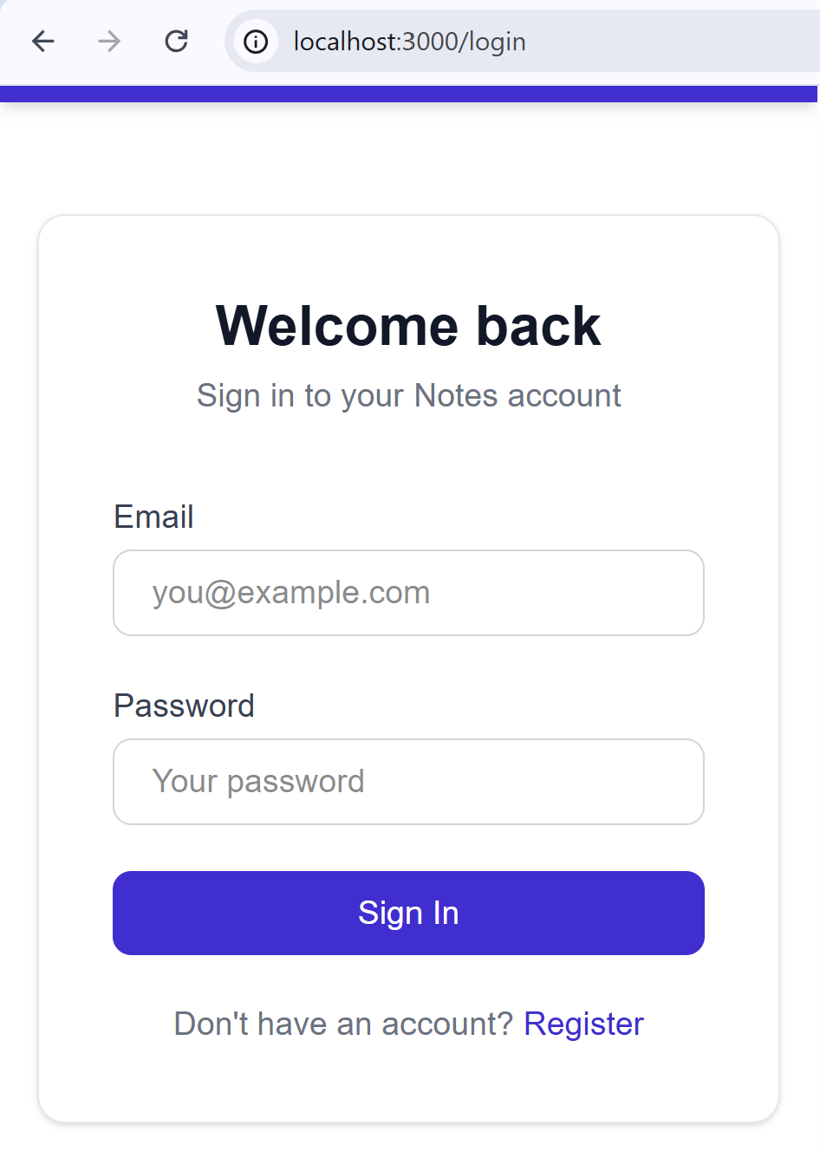

Logged In User Profile
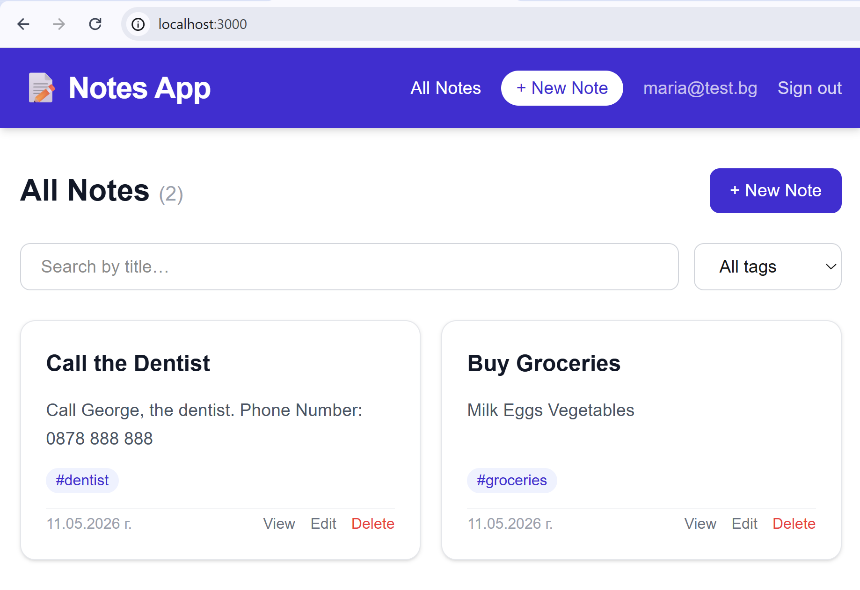

Movie Watchlist
Build a personal movie watchlist app:
  - Anonymous visitors see a public home page with popular / recently added movies
  - Admins manage movies (add / edit / delete)
  - Registered users manage their own watchlist (add movies, mark as watched, rate, review)
  - Use Next.js + Neon + Drizzle + server components + server actions (no REST API) + middleware

Step 1. Setup the Project
Create a new workspace in VS Code, e.g. `movie-watchlist`. Initialize a Next.js project with TypeScript, Tailwind and App Router.

Step 2. Create a Neon DB
Create a new Neon project: `MoviesDB`.

Step 3. Connect Neon MCP
This step is optional. You can go ahead without Neon MCP. It may help you to debug some situations, but is not required to build the app.
- Open the Extensions section in VS Code and type `@mcp neon` in the search bar. Select [Install in Workspace]
- Allow authorization of the MCP to your Neon account
- Add the Neon database name in `AGENTS.md` to avoid ambiguity when using Neon MCP
- Test the MCP server. Run `Show DB info` in the AI Chat

Step 4. Configure Neon DB Connection
Configure Neon DB connection in your Node.js project (use Neon MCP).
The goal is to have your database connection string properly configured in your project's .env file.

Step 5. Initialize Database
Initialize the database, generate DB schema and seed sample data.
- Install Drizzle ORM + Neon drivers + bcrypt from npm
- Define the schema with Drizzle:
  - users: id, email, passwordHash (bcrypt), name, role (user | admin), created_at
  - movies: id, title, slug, description, year, director, genre, poster_url, created_at
  - user_movies: id, movie_id (FK), user_id (FK), status (to_watch | watching | watched), rating (1-10, nullable), review (text, nullable), created_at
- Create and run a Drizzle migration: use `npm db:generate` + `npm db:migrate`
- Seed sample data: 10-15 movies + 2 users + 5-10 movies per user watchlist (use `npm db:seed`)

Sample AI Prompt
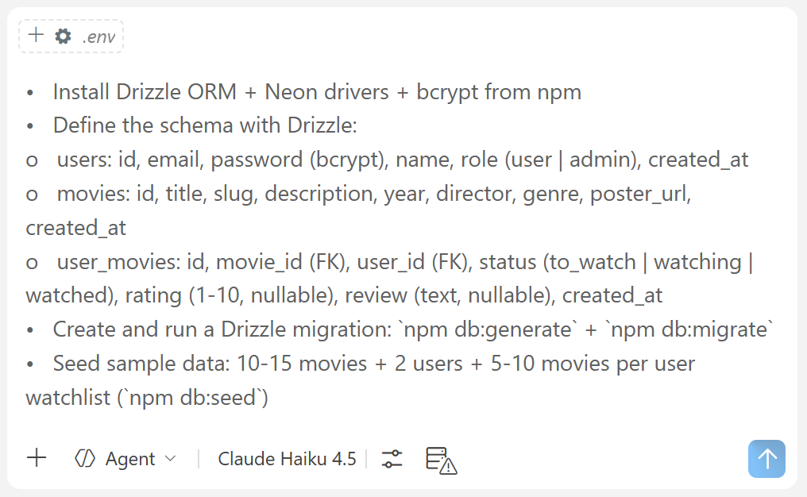

The Result – Tables in Neon DB
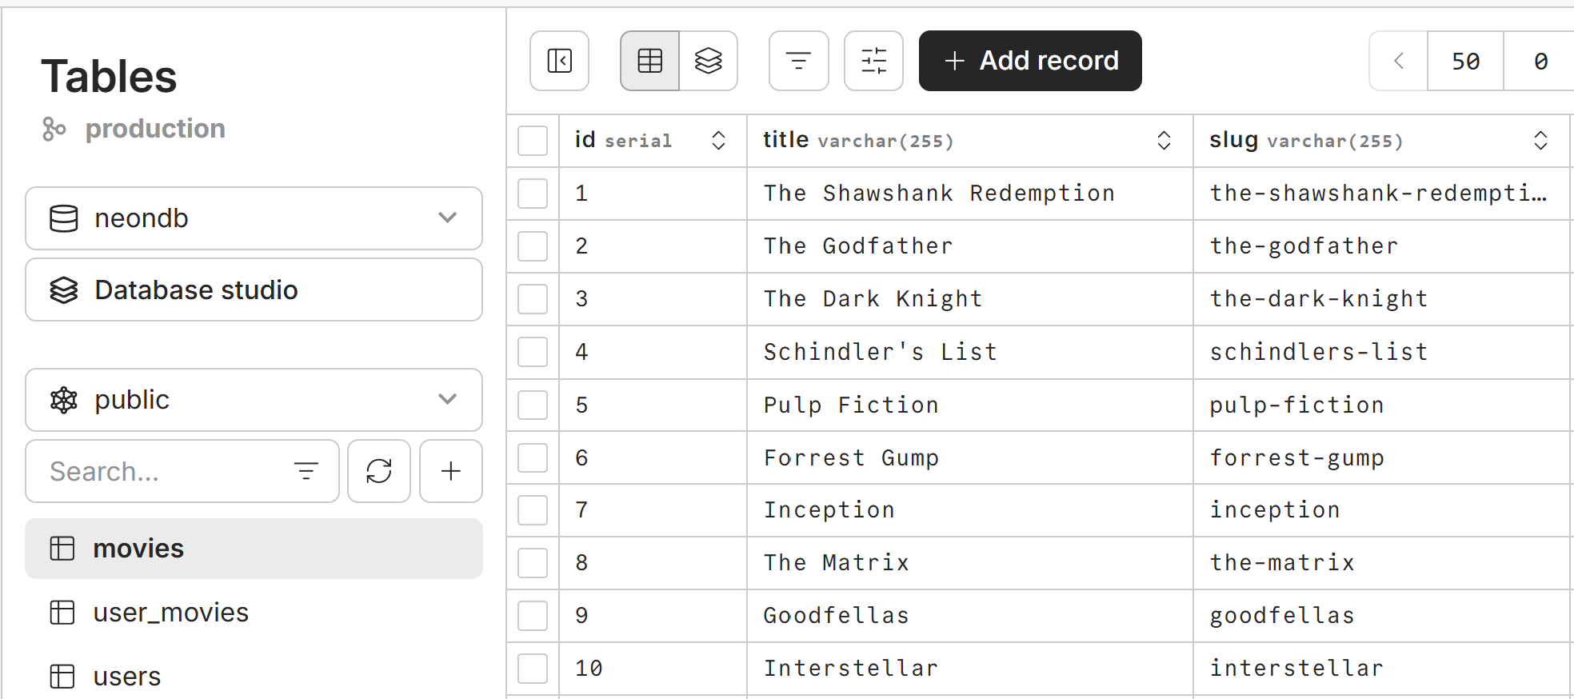

Step 6. Public Pages (SSG / ISR)
Implement the app public pages:
- `/` – Home page (ISR, revalidate every 10 min)
  - Hero section + recently added movies across all users (public feed)
  - Links to Login / Register
- `/movies`, `/movies/[slug]` – public pages to browse / view movies (with server-side paging)
- `/about` – static page describing the app
- App layout: header + nav link + footer
- When logged-in display "Logout" in the nav links, otherwise "Login" / "Register"

Sample AI Prompt
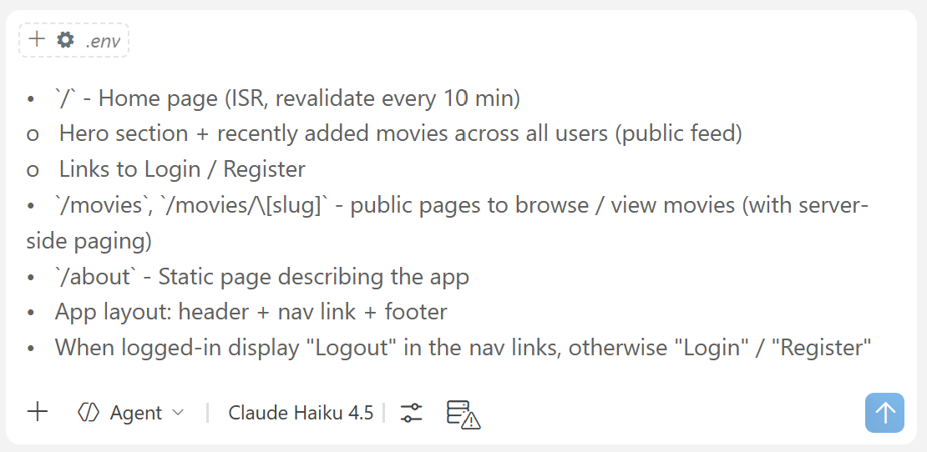

The Result – App Public Pages

The Homepage
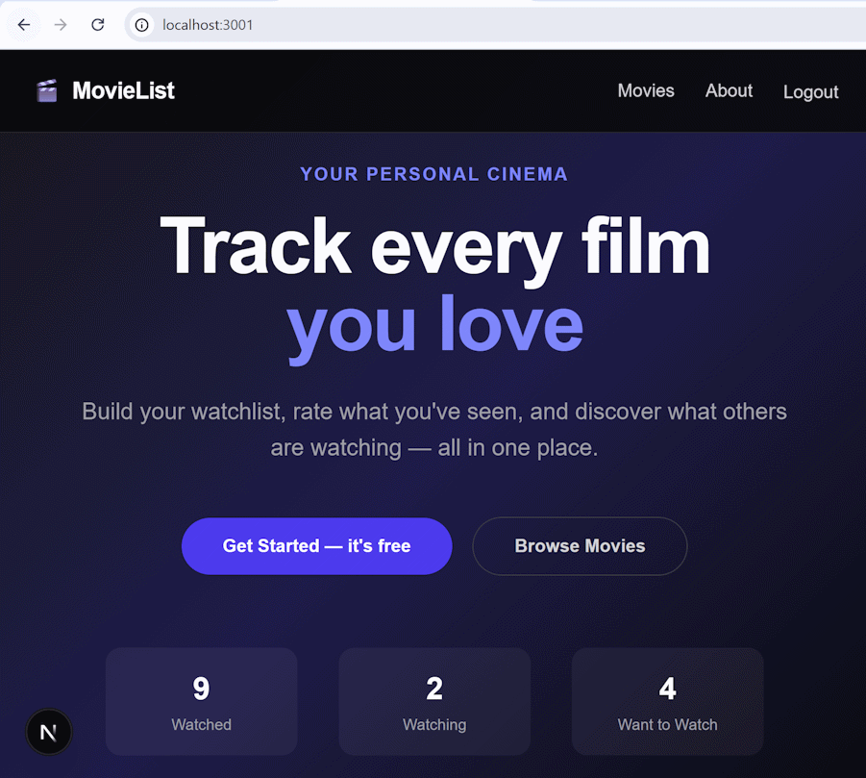

The Sample Movies
Fill real movies in the DB, with real posters, to get something like this:
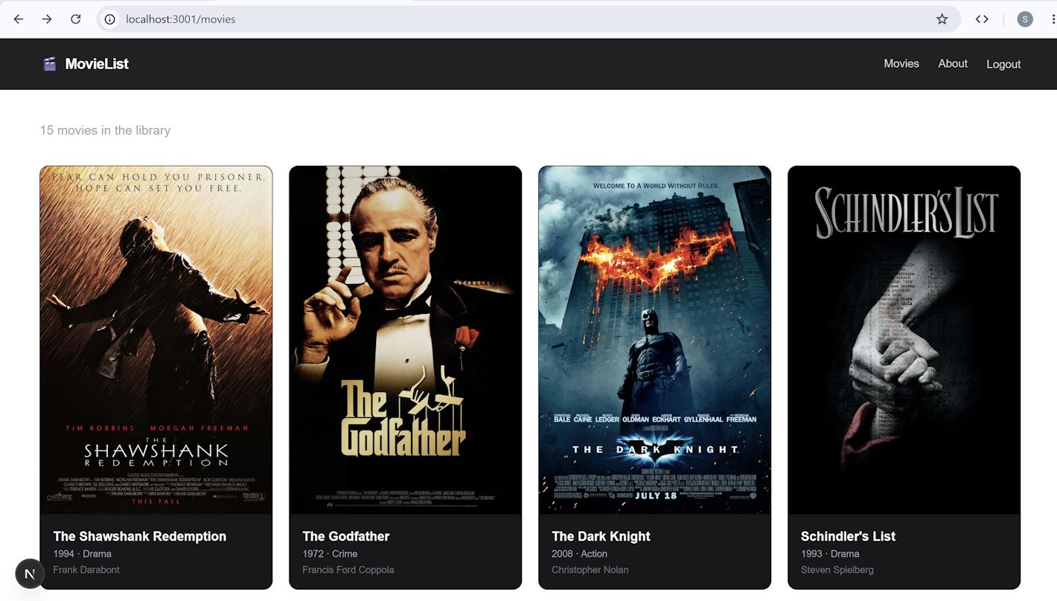

Step 7. Users and Auth
Implement users (login, register, logout), with JWT and bcrypt.
- Configure `.env`: add random JWT_SECRET
- Auth pages (static): (auth)/login, (auth)/register, (auth)/profile
- Client components: `UserRegister`, `UserLogin`, `UserProfile`
- Server actions: `registerUser`, `loginUser`, `logoutUser`
- Hash / verify user password with bcrypt
- On success, set an HTTP-only cookie with a signed session token (use JWT_SECRET)

Sample AI Prompt
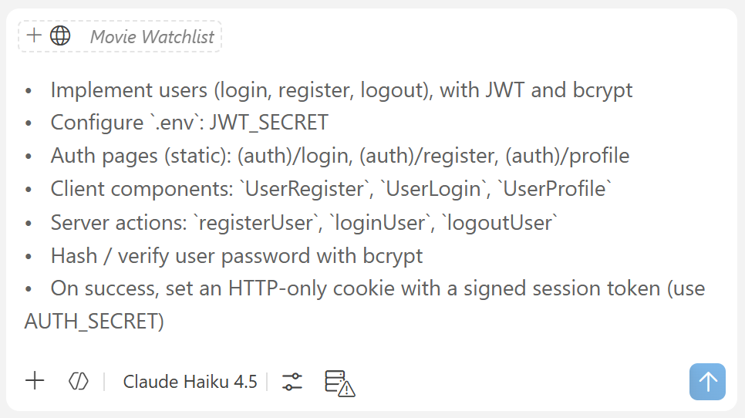

The Result – Auth Pages
Now we have the auth pages for our app:
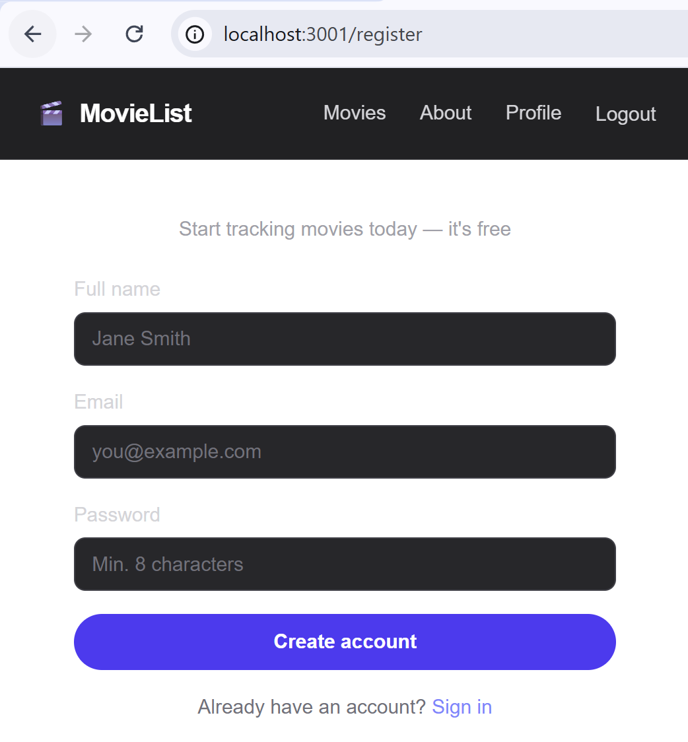

Step 8. User Pages
Implement user dashboard pages:
- `/dashboard` – user's watchlist (SSR, always fresh)
  - Reads the current user's movies directly from the DB
  - Filter by status (to_watch / watching / watched) via searchParams
  - Show [Add Movie] button
- `/dashboard/new` – add movie (client component form + server action), implement search to choose a movie
- `/dashboard/edit/[id]` – edit movie (client component form + server action)
- `/dashboard/stats` – show statistics for the current user (SSR): total movies by status, average rating, top genres
- Setup middleware (proxy) to protect non-public pages
  - Implement `proxy.ts` to intercept incoming HTTP requests
  - Read and verify the auth cookie
  - Protect user and admin routes (redirect to /login if not authenticated)

Sample AI Prompt
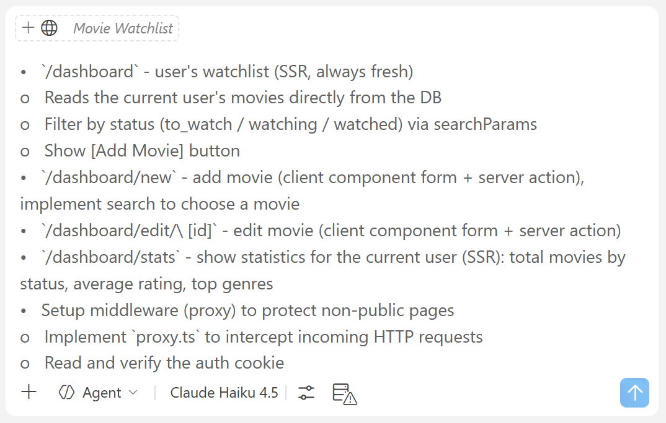

The Result – User Dashboard
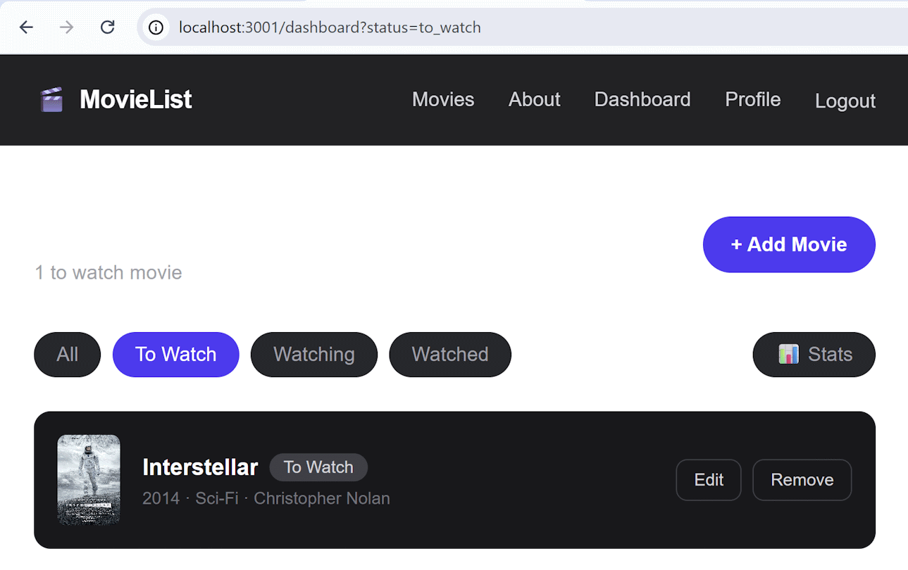

Step 9. Admin Panel
Implement Admin Panel to manage movies in the platform: /admin
- Manage Movies page: /admin/movies -> list / add / edit / delete (with search + paging)
- Server actions: `createMovie`, `updateMovie`, `deleteMovie`
- Each action verifies the current admin before editing / deleting
- Use `revalidatePath()` to refresh the affected pages after mutations

Sample AI Prompt
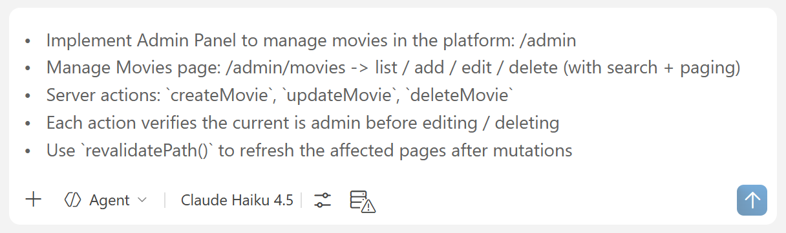

Setting Up the First Admin
The first admin should be set manually, through the Neon database. Open the `users` table and change the status of a user of your choice to `Admin` by double-clicking the `role` cell:
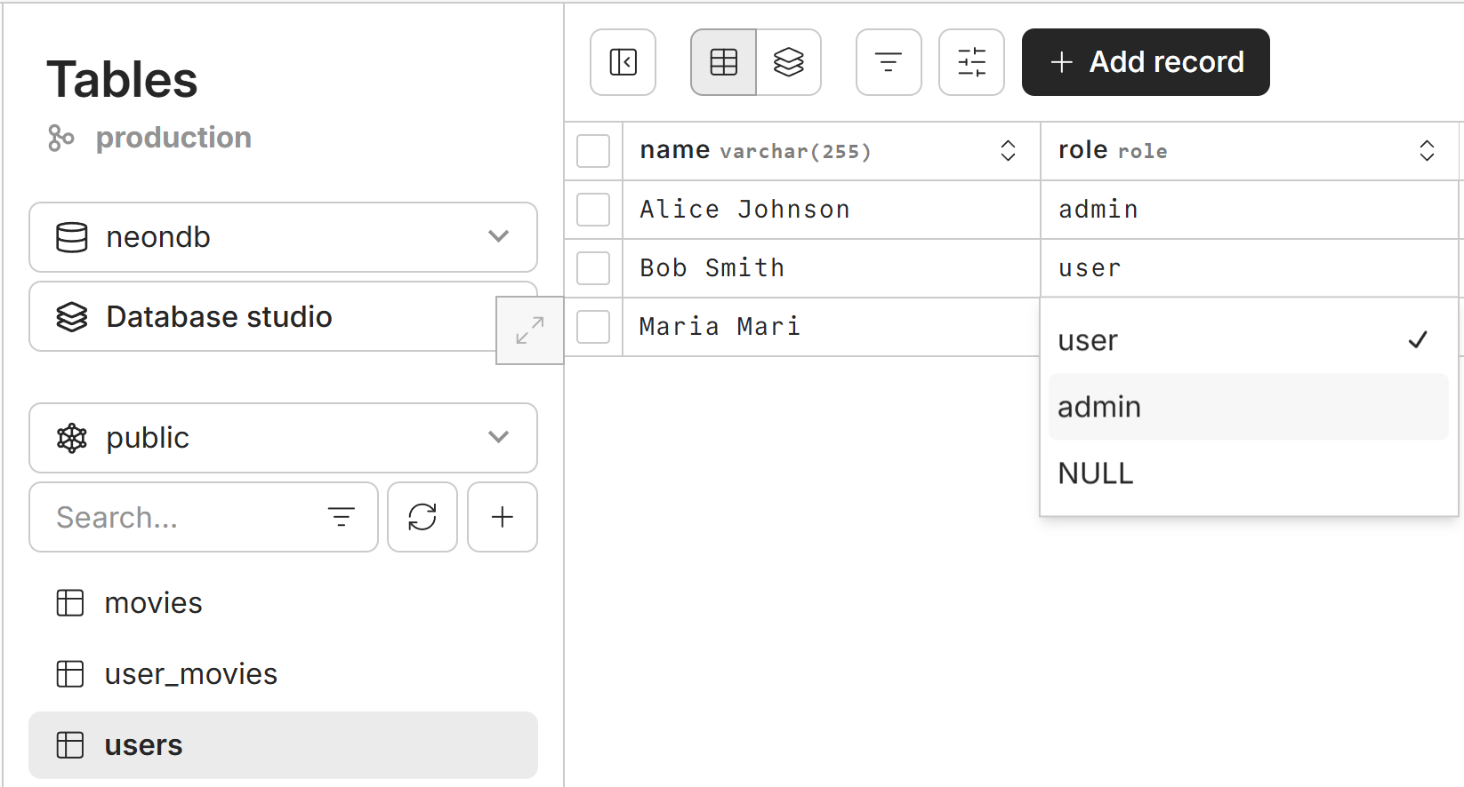

The Admin Panel
Now test the admin page. Login as admin a see the admin panel. Test the admin functionality.
Try to access the admin panel with non-admin user.
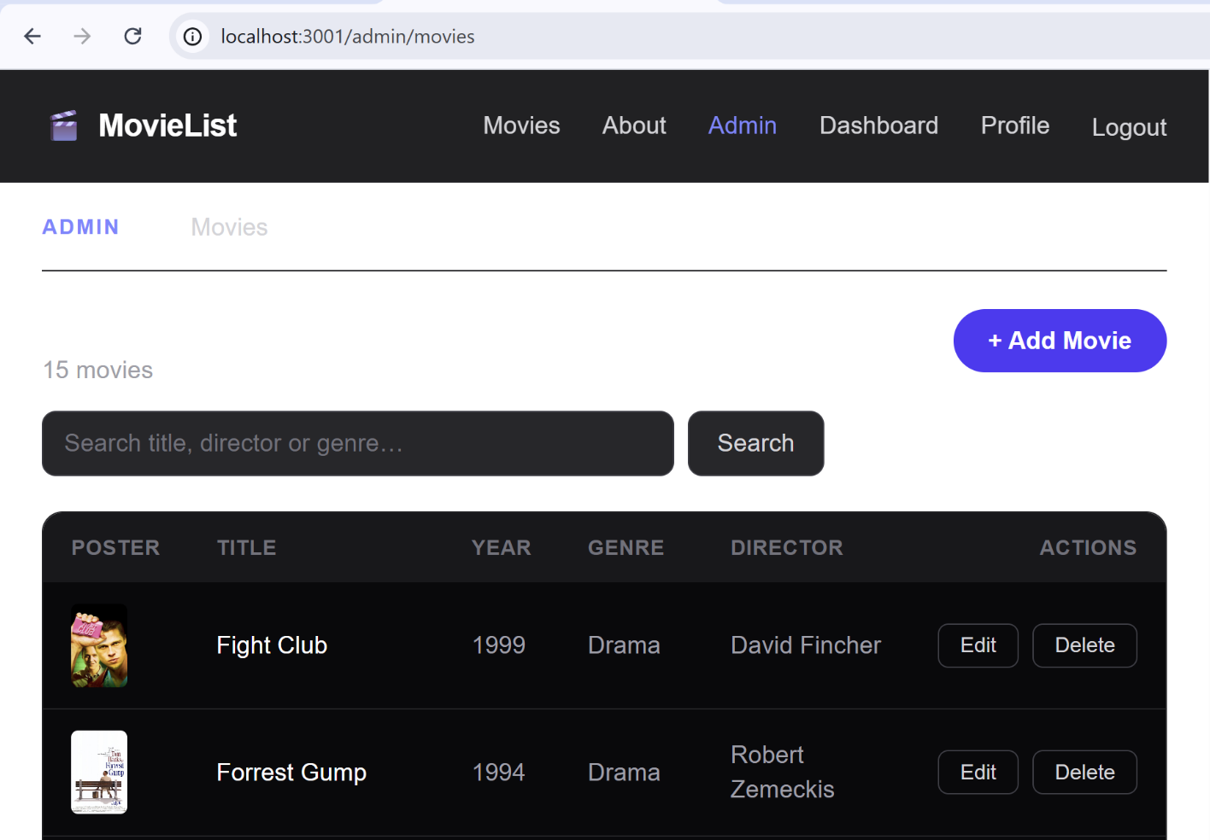

Step 10. Improve UI and UX
Improve the UI and UX and site performance, with better styling, loading indicators and prefetch links.
- Style the app with Tailwind
- Navbar shows Login / Register for anonymous users, Dashboard / Logout for logged-in users, Admin Panel for admins
- Use `<Link>` for navigation (with prefetch)
- Use `<Image>` for movie posters for improved app performance (WebP + lazy loading)
- Add `loading.tsx` for the dashboard route

Sample AI Prompt
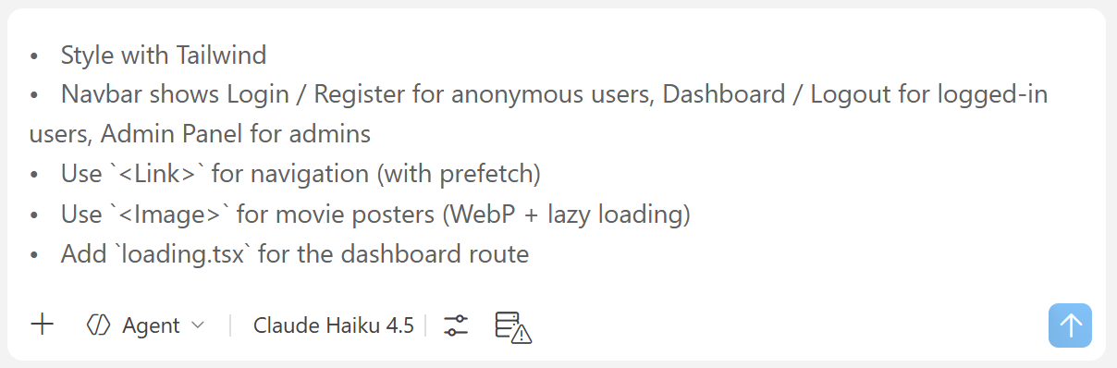

The Result – Improved UX

The Home Page
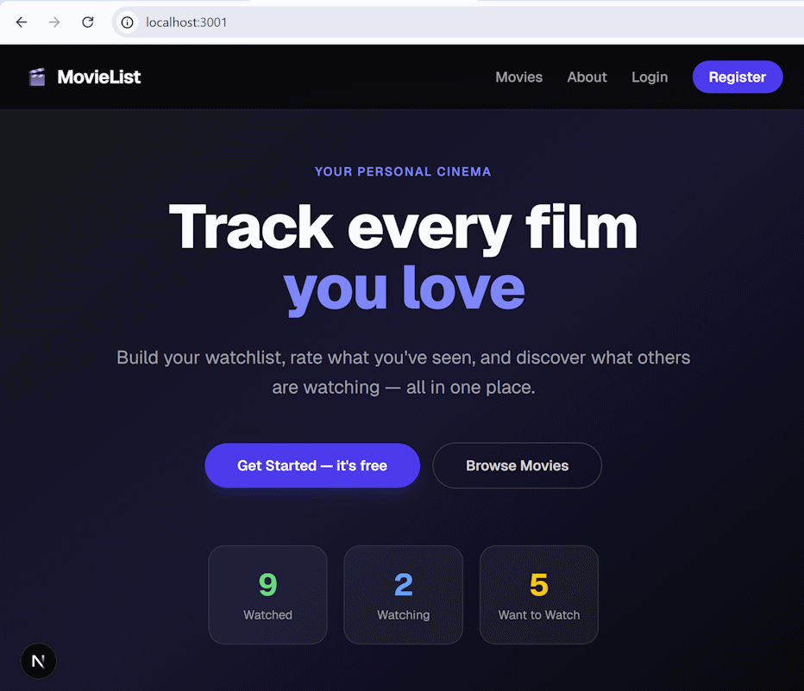

The Movie List
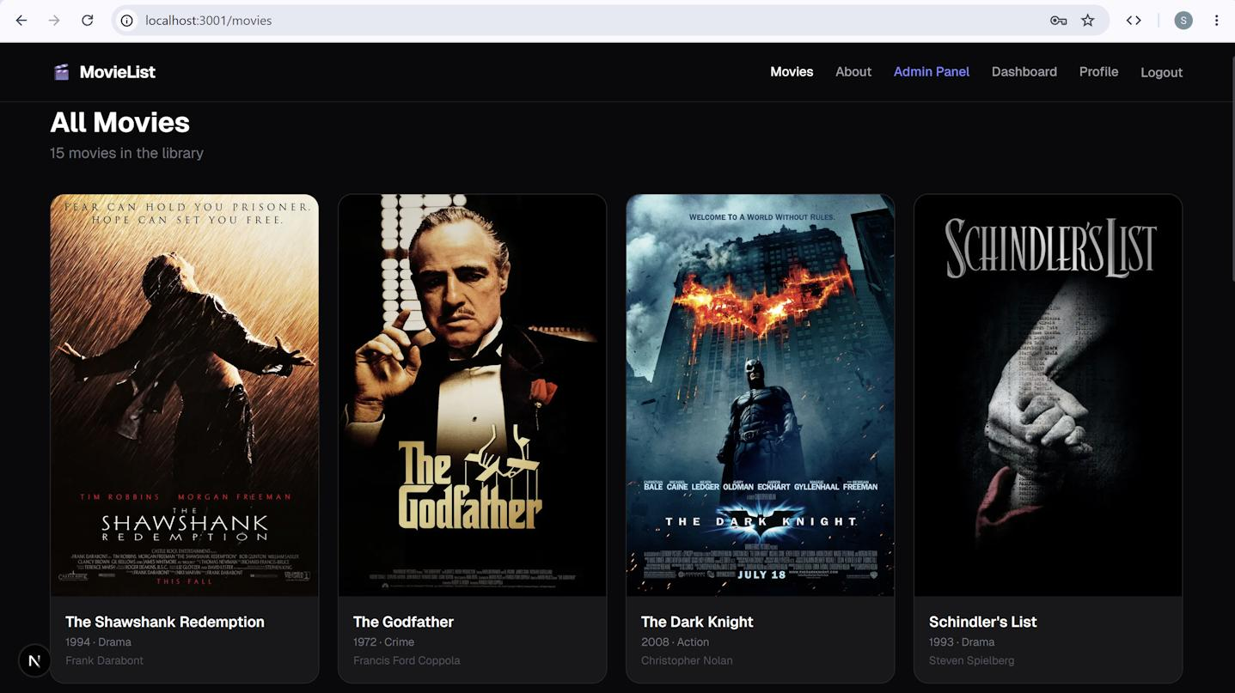

The User Dashboard
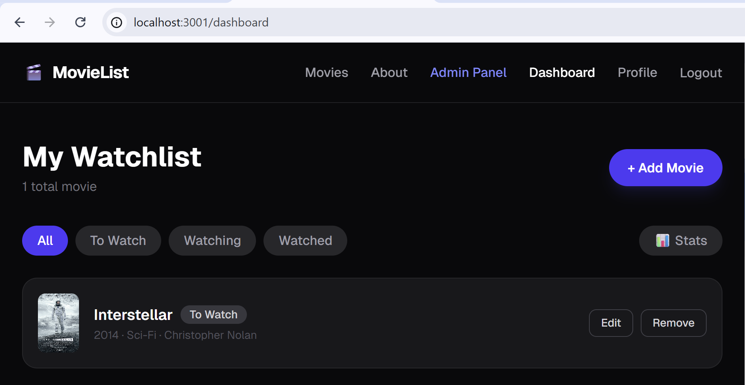

The Admin Panel
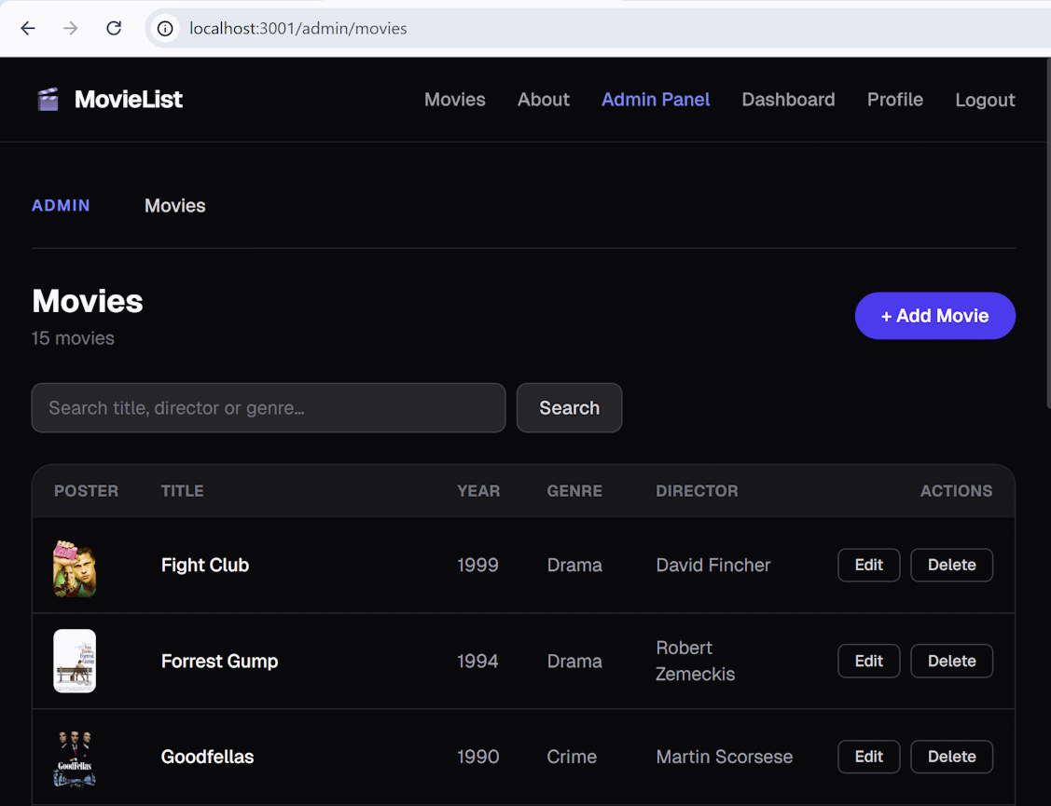

Step 10. Publish to GitHub
Publish the app to GitHub.
First, make sure `.env ` is in `.gitignore`:
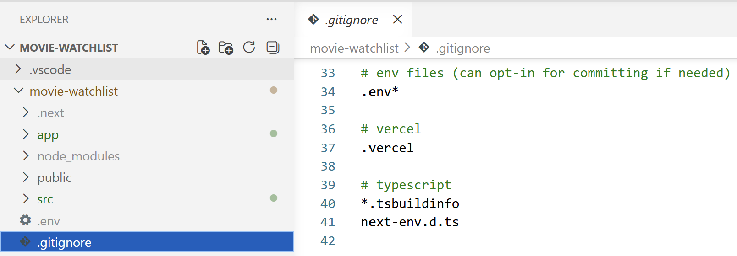
Commit the code and push it to GitHub.
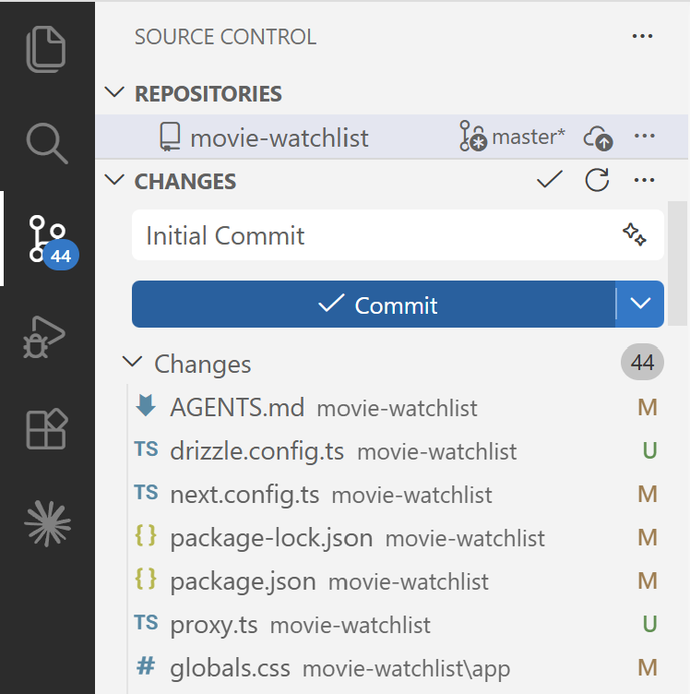
Note: You may need to change the repository visibility from Private to Public. You can do this from Settings -> [Change Visibility] at the bottom of the page.

Step 11. Deploy to Netlify
Go to Netlify -> [Add a New Project]:
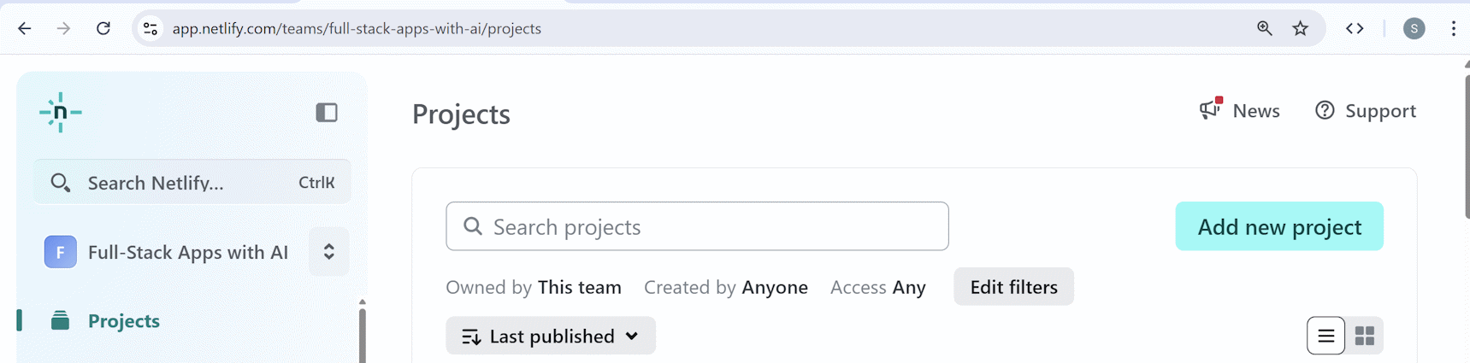
Select [GitHub] and Authorize:
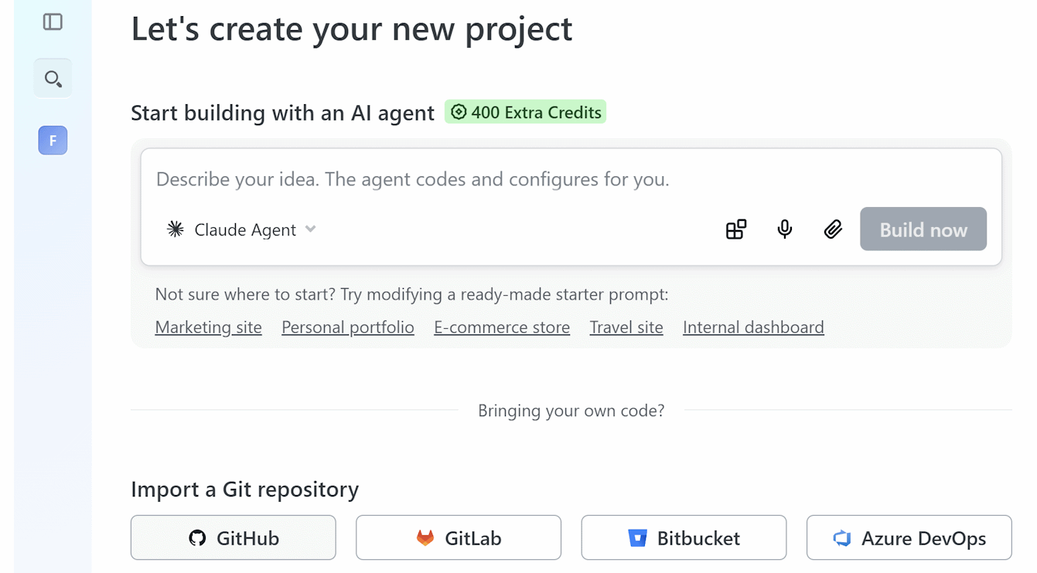
Select a Project name:
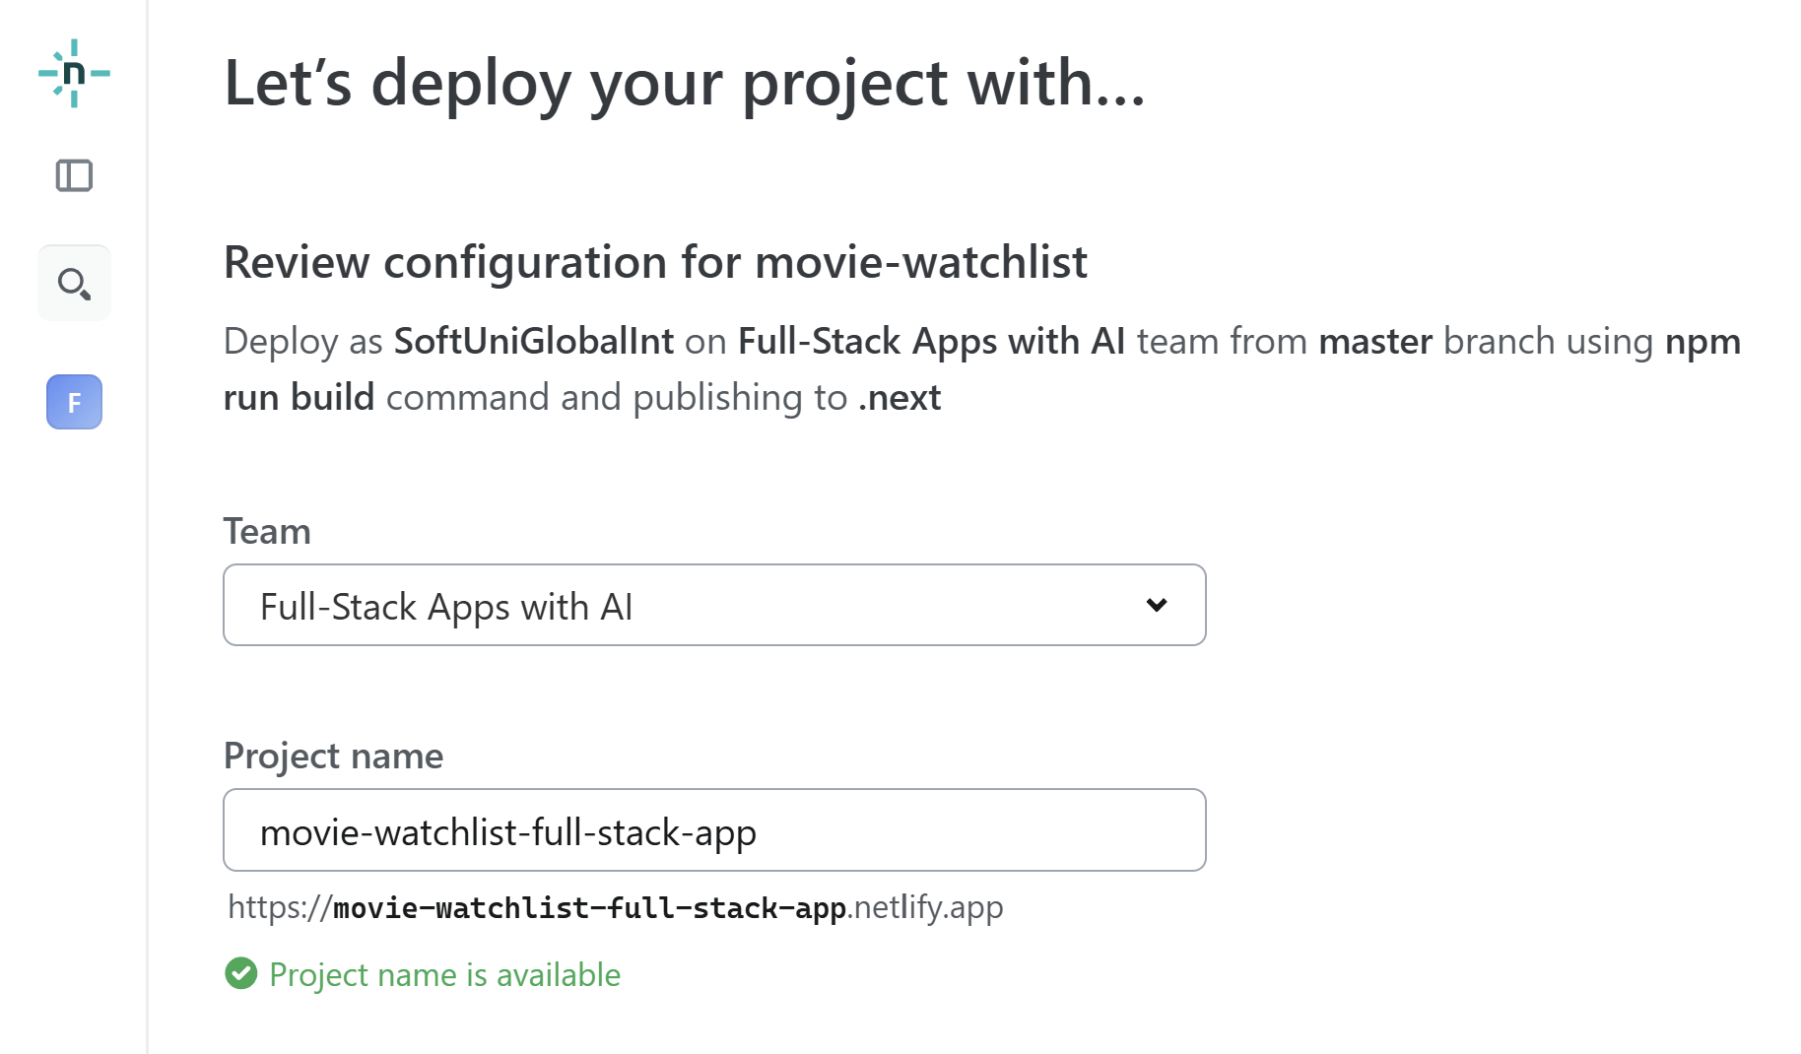
Scroll down to adding the environment variables and add them. Add ALL OF THE VARIABLES to the `.env` file, otherwise the website won’t work properly:
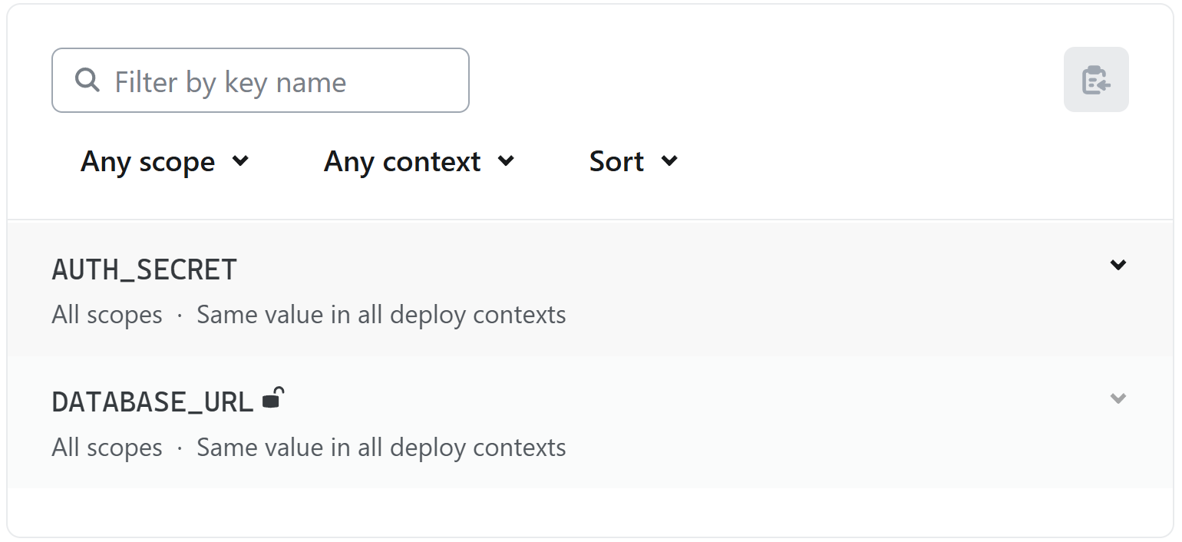
Proceed with the deployment and wait. The application will be available in [Project overview]:
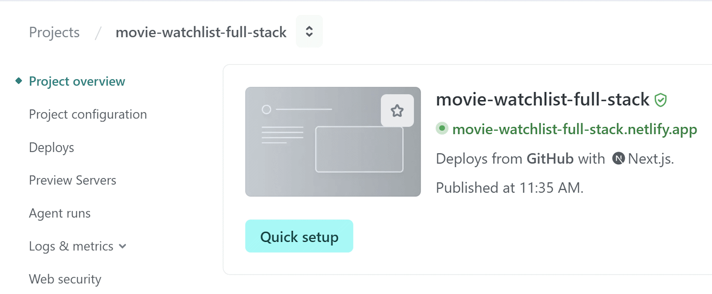

Step 12: Test the Application
Test the app from the production deployment. Verify: SEO on public pages, auth works, dashboard is protected, server actions work in production, etc.

SEO on Public Pages
Open the website on a random public page (e.g. https://your-app.netlify.app), right click and select [View Page Source]. You should see the code in a similar format:
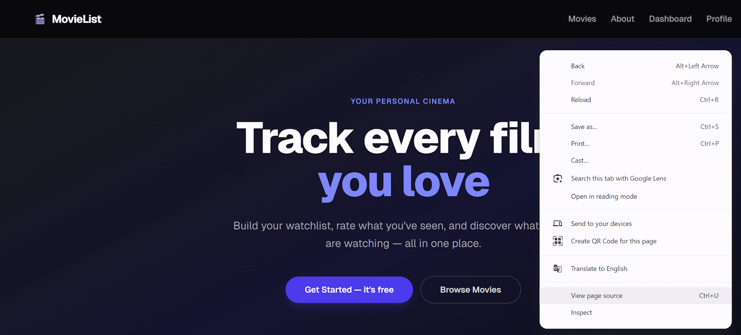
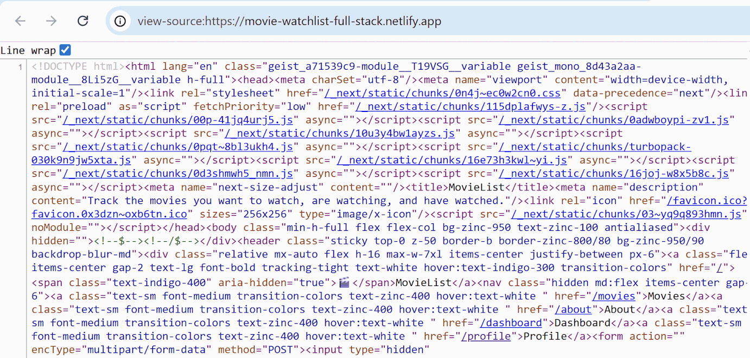
This proves that:
- SEO works as expected
- Pages are server-rendered / pre-rendered
- Metadata works

Verify Auth Works
Register an account, log in, log out.
What you should check:
- User registration works
- Login / logout works correctly
- Authenticated session persists through HTTP-only cookies
- Protected pages open after login only

Verify Dashboard Protection
Test unauthorized access. Open https://your-app.netlify.app/dashboard without login. The expected result is to be redirected to https://your-app.netlify.app/login.

Test Admin Protection
Try https://your-app.netlify.app/admin with a normal user and an unauthorized user/guest. Should be blocked/redirected.

Verify Server Actions
Test the CRUD operations:
- Add movie / edit movie / delete movie
- Add to watchlist
- Update review / rating

